**Aim** :- Orchestrating serverless functions with step functions.

**Lab overview and objectives**

In this lab, you will use AWS Step Functions to coordinate the actions necessary to generate and deliver a report upon request. The report will contain data from a database.

After completing this lab, you should be able to:

* Create an asynchronous state machine by using Step Functions
* Configure an Amazon Simple Notification Service (Amazon SNS) topic to deliver email alerts
* Configure AWS Lambda functions to be invoked from a Step Functions state machine
* Use a parallel state flow object in the design of a Step Functions state machine
* Invoke a state machine to start when a REST API endpoint is invoked
* Generate a presigned URL for an object stored in an Amazon Simple Storage Service (Amazon S3) bucket

**AWS service restrictions**

In this lab environment, access to AWS services and service actions might be restricted to the ones that are needed to complete the lab instructions. You might encounter errors if you attempt to access other services or perform actions beyond the ones that are described in this lab.

**Scenario**

Thanks to Sofía, the coffee suppliers inventory now automatically updates on the café website. But the work is not finished! Frank asks if it would be possible to log in to the website to request a report with the latest inventory information.

Yesterday, Mateo, who is an AWS consultant and Sofía's friend, came into the café for a macchiato, his favorite espresso drink. While he was enjoying his beverage, Sofía told him about how she needs to build a reporting mechanism for Frank. After discussing the high-level business requirements, Mateo suggested that she use AWS Step Functions to coordinate the steps to generate the report. He described how Step Functions can help a developer to automate business processes by creating workflows, and providing parallelization and service integrations, among other features.

X`In this lab, Sofía will build the functionality to create and deliver the report. Then, in the next lab, she will improve the design further and implement authentication on the website to limit who can request and access reports.

**Task 1: Preparing the lab**

Connect to the VS Code IDE.

1. At the top of these instructions, choose Details followed by **AWS: Show**
2. Copy values from the table **similar** to the following and paste it into an editor of your choice for use later.
   * **LabIDEURL**
   * 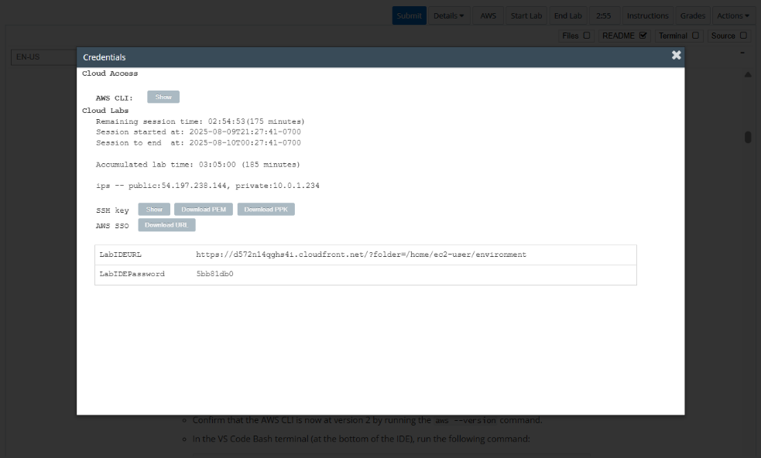**LabIDEPassword**
3. In a new browser tab, paste the value for **LabIDEURL** to open the VS Code IDE.
4. On the prompt window **Welcome to code-server**, enter the value for **LabIDEPassword** you copied to the editor earlier, choose **Submit** to open the VS Code IDE.

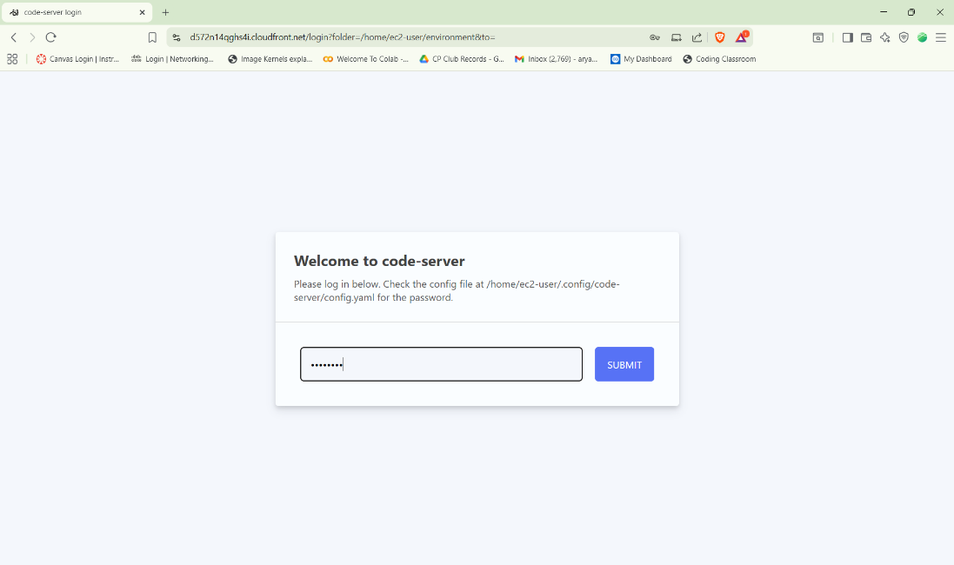

1. Download and extract the files that you need for this lab.

* In the VS Code bash terminal (located at the bottom of the IDE), run the following commands:

**wget https://aws-tc-largeobjects.s3.us-west-2.amazonaws.com/CUR-TF-200-ACCDEV-2-91558/11-lab-step/code.zip -P /home/ec2-user/environment**

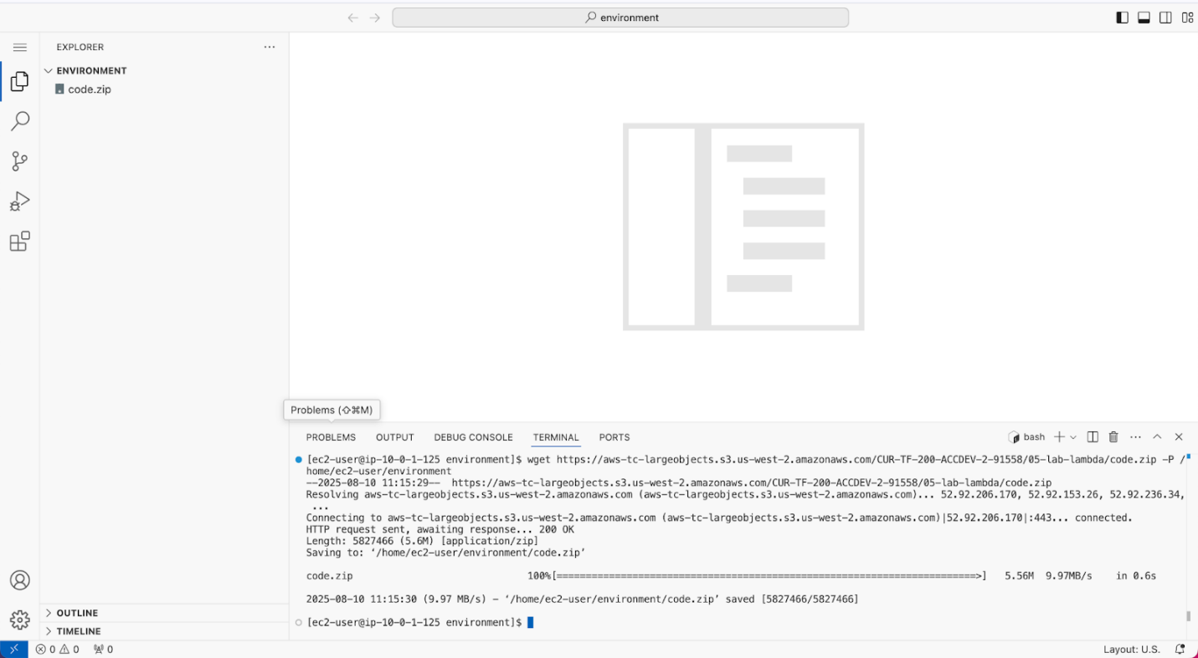

1. You should see that the **code.zip** file was downloaded to the VS Code IDE and is now in the left navigation pane.

* Extract the file by running the following command:

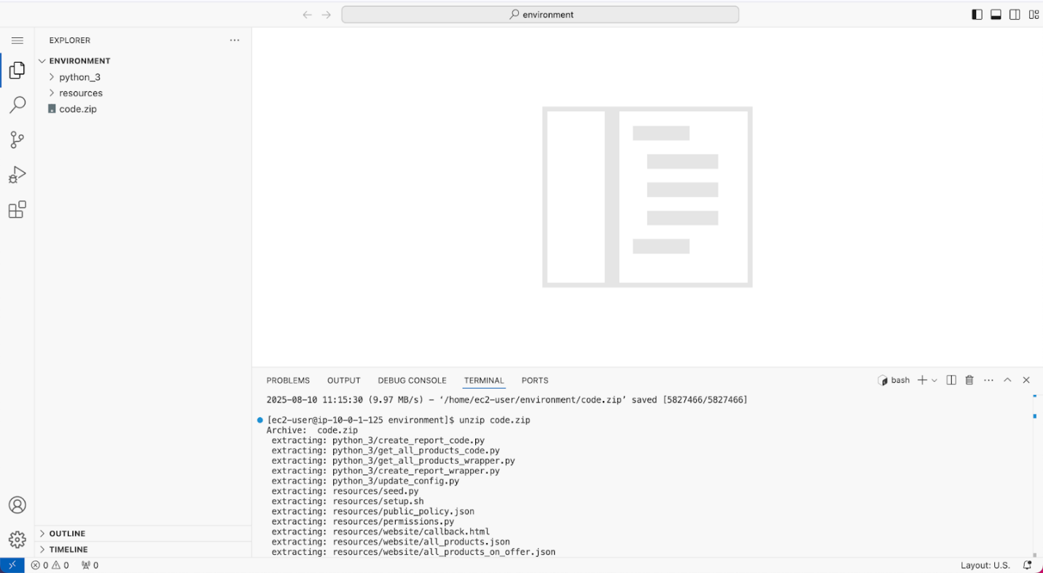unzip code.zip

1. Run a script that upgrades the version of the AWS CLI installed on the VS Code IDE.

* To set permissions on the script and then run it, run the following commands in the Bash terminal:

chmod +x ./resources/setup.sh && ./resources/setup.sh

The script will prompt you for the **IP address** by which your computer is known to the internet.

Use [www.whatismyip.com](http://www.whatismyip.com/) to discover this address and then paste the IPv4 address into the command prompt and finish running the script.

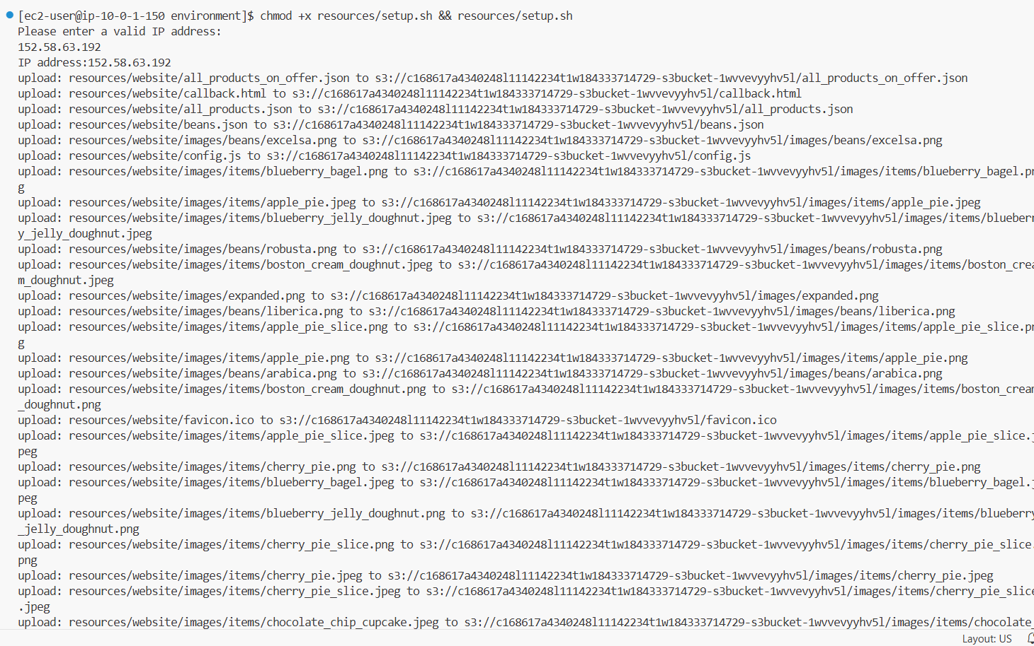

1. Verify the AWS CLI version and also verify that the SDK for Python is installed.

* Confirm that the AWS CLI is now at version 2 by running the **aws --version** command.
* In the VS Code Bash terminal (at the bottom of the IDE), run the following command:

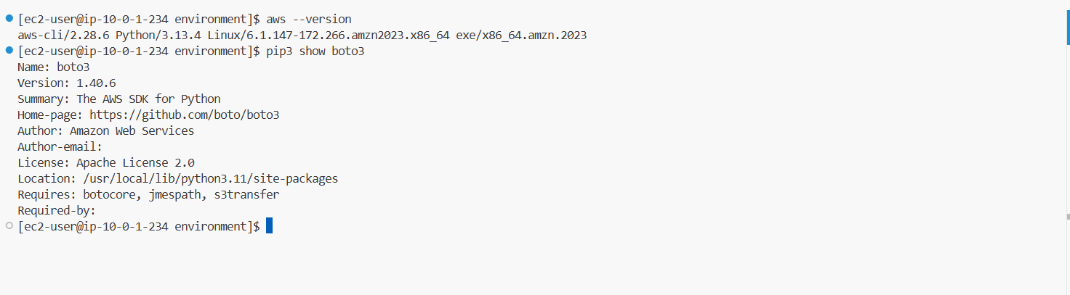**pip3 show boto3**

1. Verify that you can access the café website.

* Navigate to the Amazon S3 console.
* Choose the link for the bucket that has *-s3bucket* in the name.
* Open the **index.html** file.
* 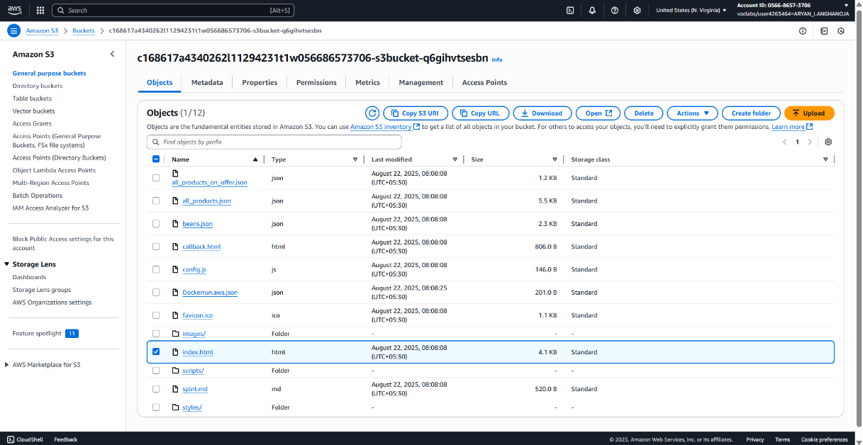In the **Object overview** section, open the **Object URL** in a new browser tab.

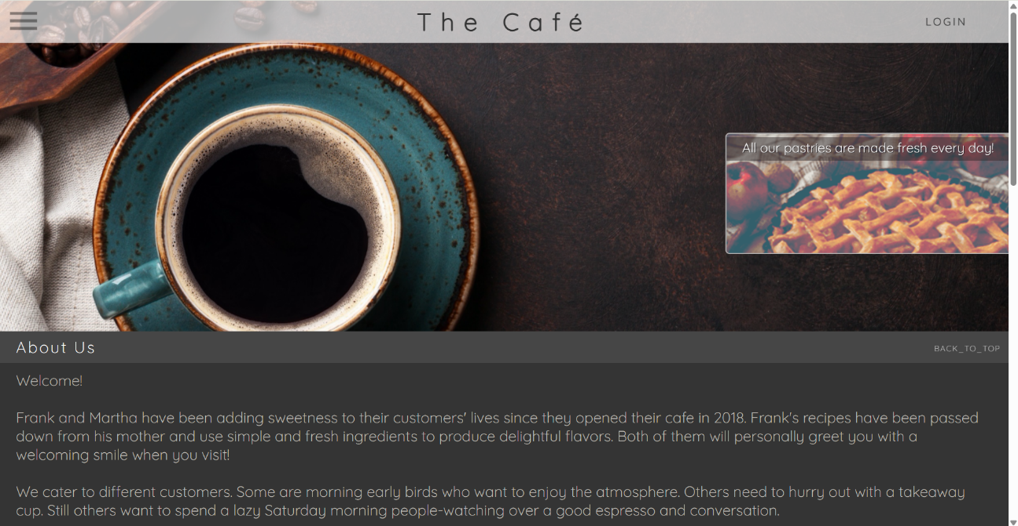

**Task 2: Configuring an SNS topic and subscribing to it**

1. Create an SNS topic for email notification.
   * Navigate to the Amazon SNS console.
   * In the left navigation pane, choose **Topics**.
   * Choose **Create topic** and configure the following:
     1. **Type**: Choose **Standard**.
     2. **Name**: Enter EmailReport
     3. Expand the **Access policy - *optional*** section.
     4. **Define who can publish messages to the topic**: Choose **Everyone**.
     5. **Define who can subscribe to this topic**: Choose **Everyone**.
   * 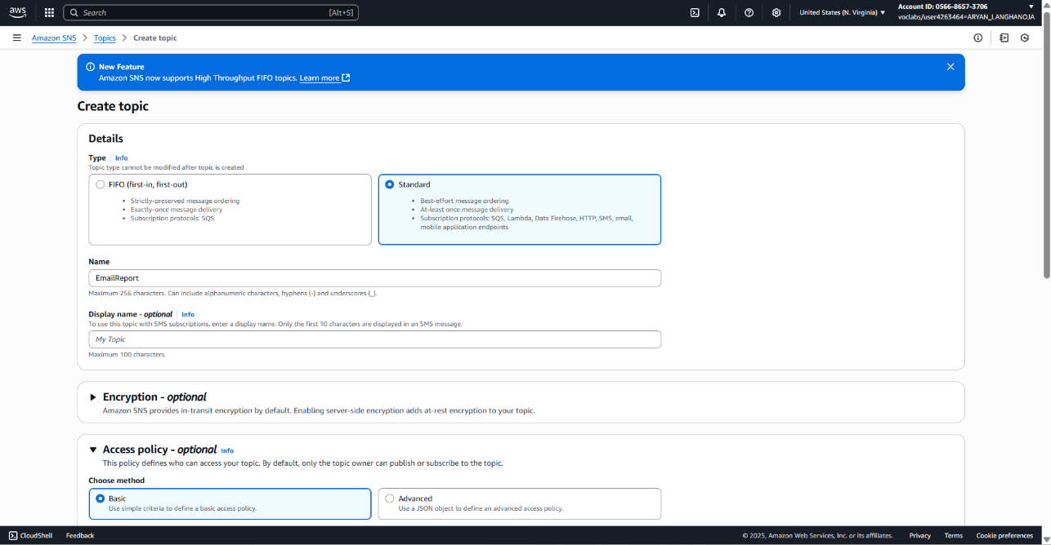At the bottom of the page, choose **Create topic**.
2. Create an email subscription to the SNS topic.
   * Choose Create subscription and configure the following:
     1. Topic ARN: Notice that the Amazon Resource Number (ARN) of the topic that you just created is already filled in.
     2. Protocol: Choose Email.
     3. Endpoint: Enter an email address where you can receive emails during this lab. (In the café story, Sofía would enter Frank's email address.)
   * Choose Create subscription.

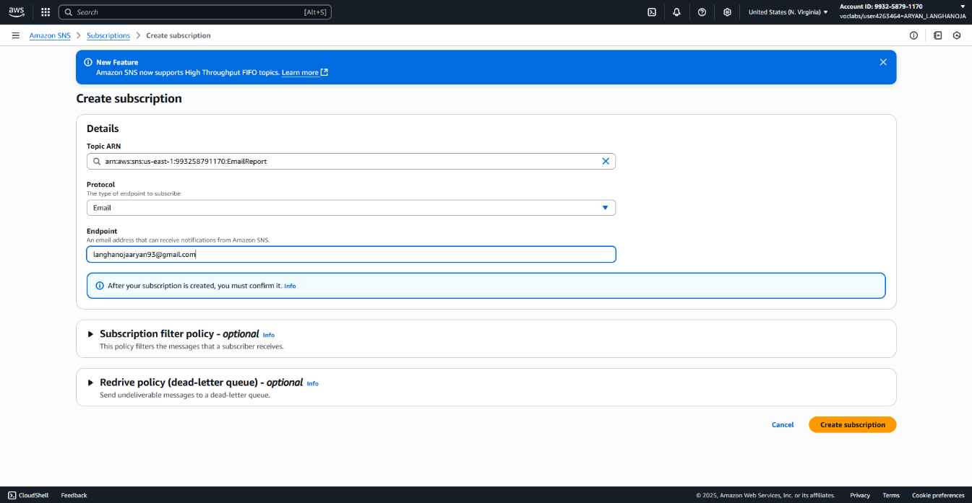

1. Check your email and confirm the subscription.

* Check your email for a message from AWS Notifications.
* In the email body, choose the Confirm subscription link.
* A webpage opens and displays a message that the subscription was successfully confirmed.

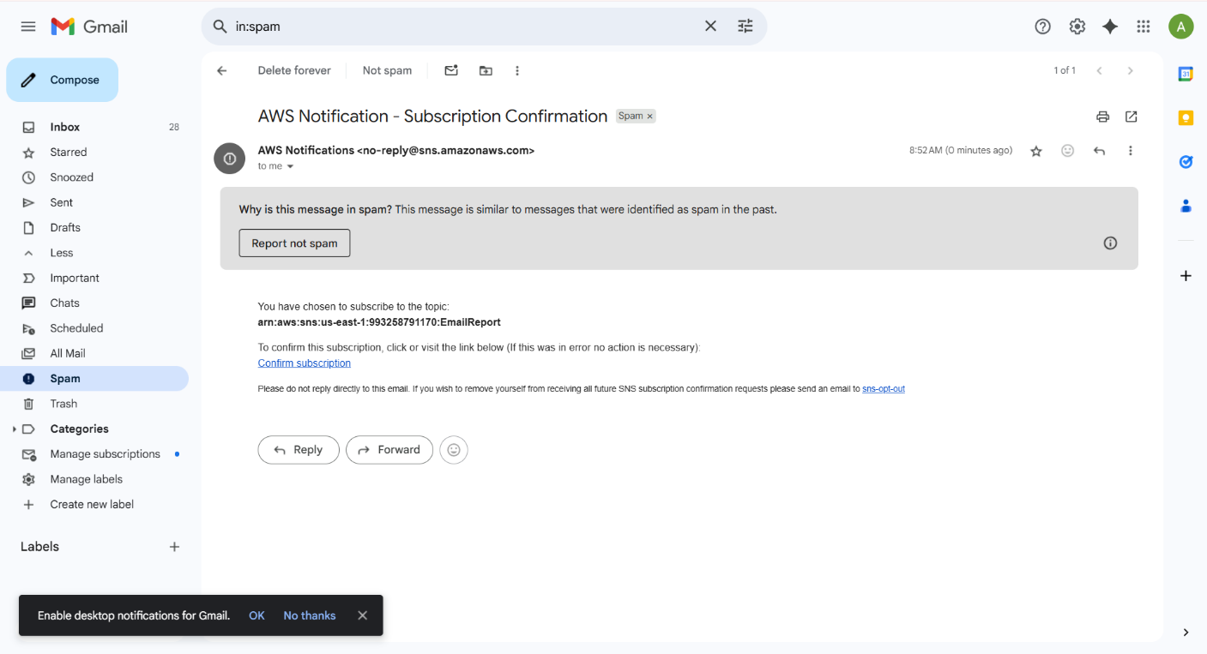

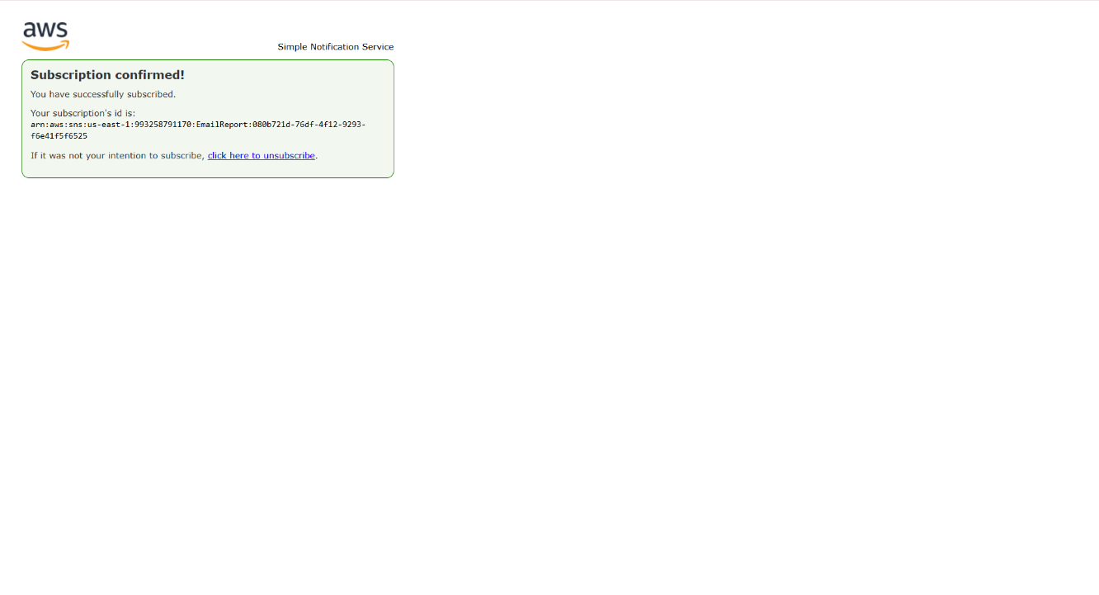

1. Publish a test message to confirm that messages can be published to the *EmailReport* SNS topic.

* Return to the Amazon SNS console, and return to the EmailReport topic page.
  + **Tip**: In the breadcrumbs at the top of the page, choose **EmailReport**.
* Choose **Publish message** and configure the following:
  + **Subject - *optional***: Enter Test
  + 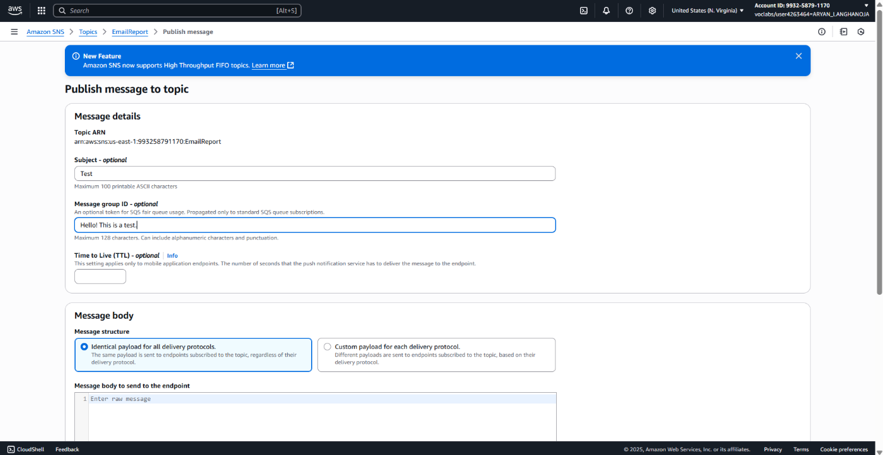**Message body**: Enter Hello! This is a test.
* At the bottom of the page, choose **Publish message**.

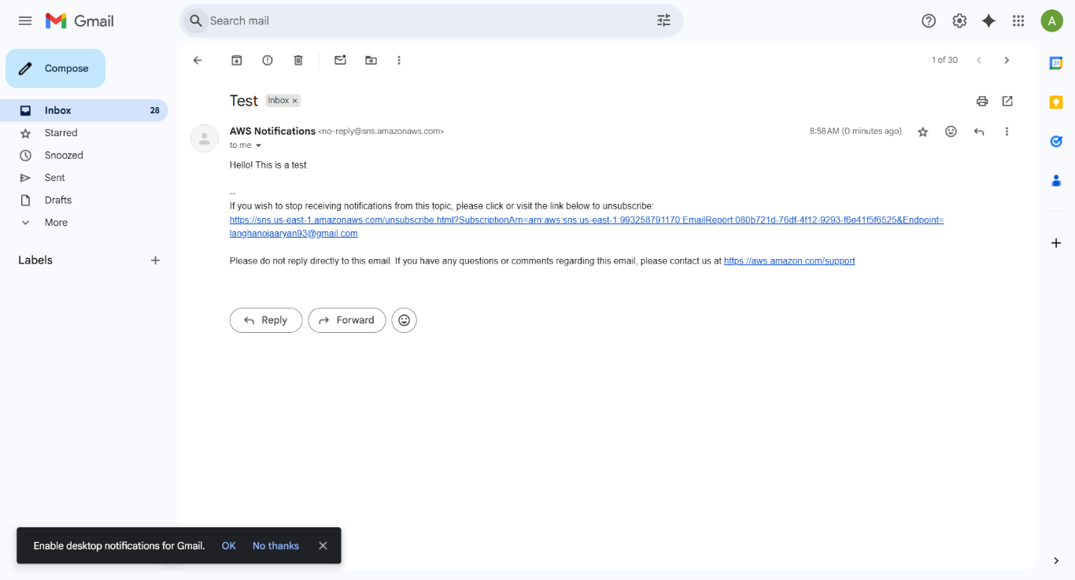

**Task 3: Creating a Step Functions state machine**

1. Analyze the details of the IAM role that Step Functions will use.

* Navigate to the IAM console.
* Review the details of the *RoleForStepToCreateAReport* IAM role.
  + In the left navigation pane, choose Roles.
  + In the search box under Roles, search for and choose the RoleForStepToCreateAReport role.
  + On the Permissions tab, expand the stepPolicyForCreateReport policy, and choose {} JSON.

Notice that this role allows all Lambda and log actions on all resources.

* + Expand the AWSLambdaRole managed policy, which is also attached to the role.

Notice that this role allows the *lambda:InvokeFunction* action on all resources. This will allow you to test the function from the Lambda console.

* + Choose the Trust relationships tab.

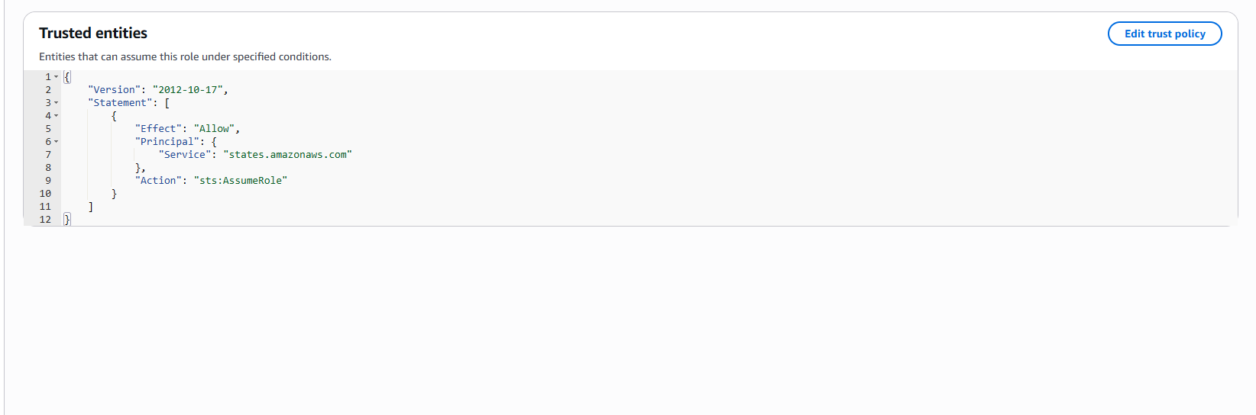

1. Begin to create a Step Functions state machine.

* Navigate to the Step Functions console.
* In the left navigation pane, choose State machines.
* Choose Create state machine and configure the following for step 1:
  + Choose a template: Choose Blank.
  + Choose Select.

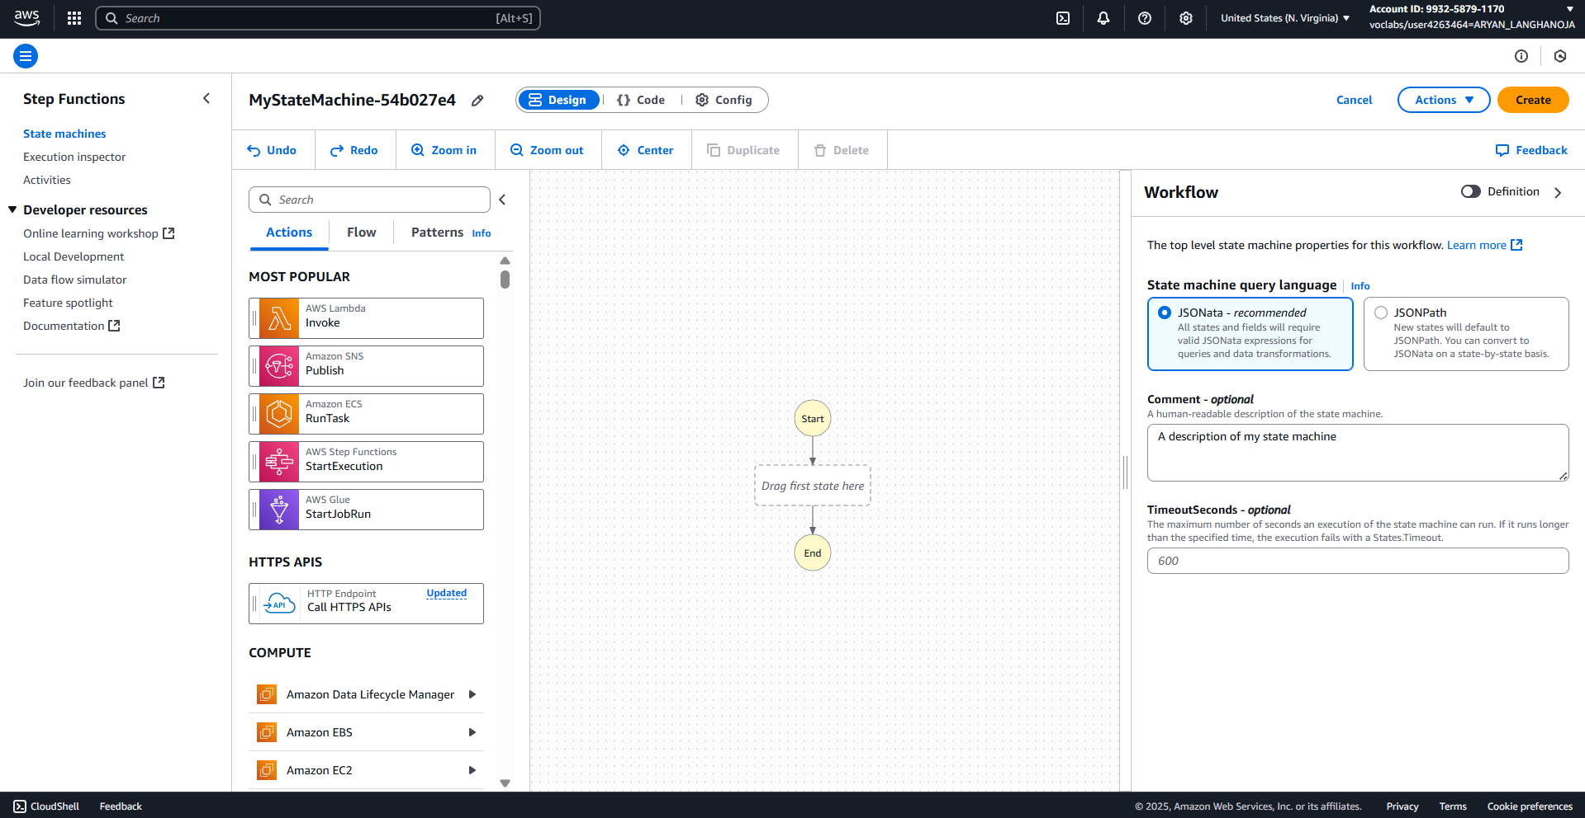The Workflow Studio appears for step 2.

1. Design the workflow.

* In the search box under Step 2: Design workflow, enter SNS
* Drag the Amazon SNS Publish object onto the canvas, to the box labeled *Drag first state here*.
* In the SNS Publish pane that displays, configure the following:
  + Topic: Choose the ARN of the EmailReport SNS topic that you created earlier.
  + Notice that Message is set to Use state input as message, as shown in the followingimage.
* Choose {} Code in the upper part of the screen.
* The generated Amazon States Language (ASL) code for the state machine displays, as shown in the following image.
* Choose {} Code in the upper part of the screen.
* The generated Amazon States Language (ASL) code for the state machine displays, as shown in the following image.

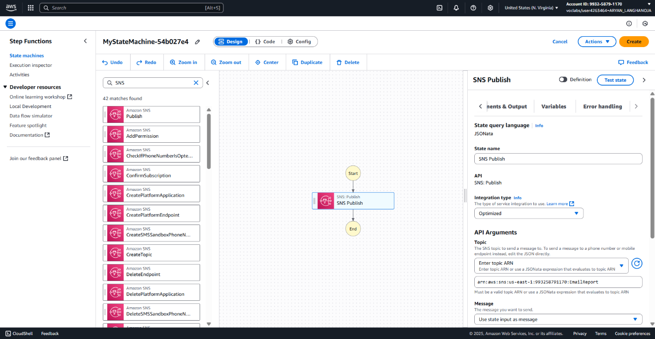

* Choose {} Code in the upper part of the screen.
* The generated Amazon States Language (ASL) code for the state machine displays, as shown in the following image.
* Choose **Config** and configure the following:
  + **State machine name**: Enter MyStateMachine
  + **Execution role**: Choose **Choose an existing role**.
  + **Existing roles**: Choose **RoleForStepToCreateAReport**.
  + **Log level**: Choose **ALL**.
* At the top of the page, choose **Create**.

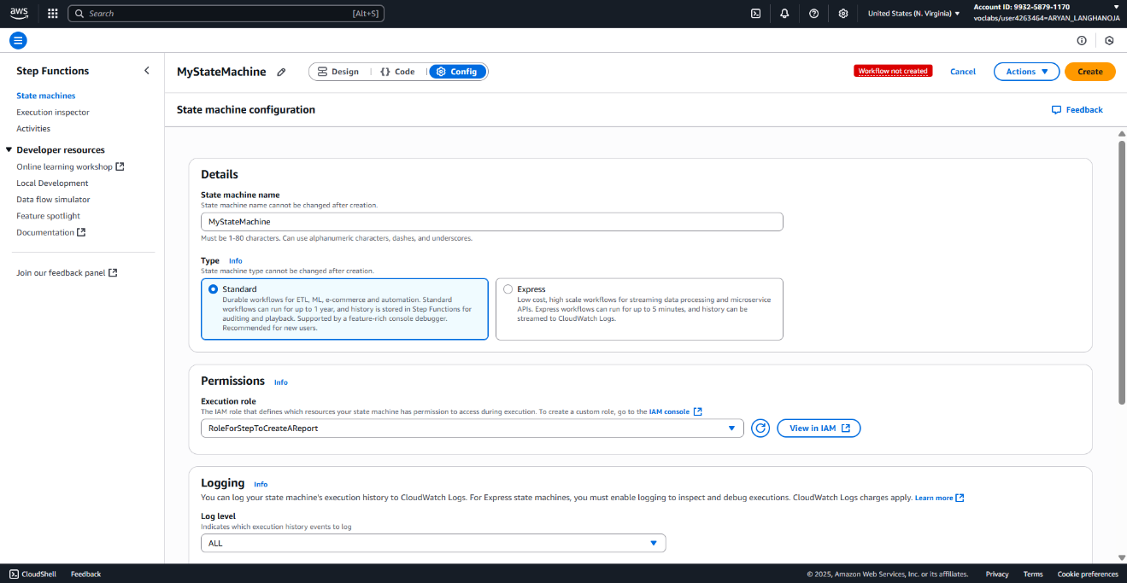

1. Test the state machine.

* Choose **Execute** button at the top and configure the following:
* In the code editor, replace the existing JSON code with the following.

{

 "presigned_url_str": "Testing that my email message works"

}

* Choose **Start execution**.
* A message displays and indicates that the execution started successfully.
* To see the details, choose **Execution input and output**.
* 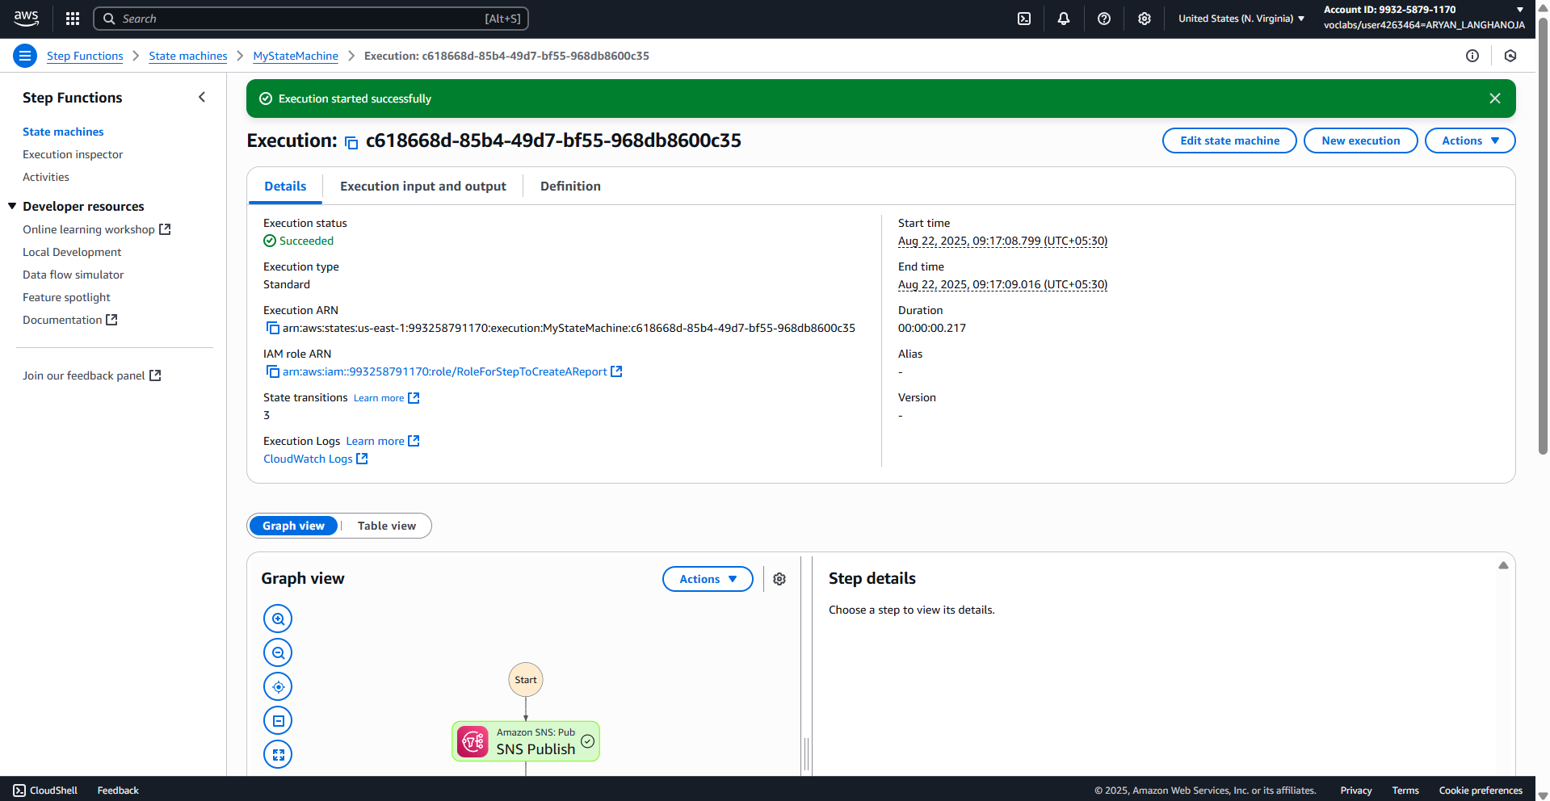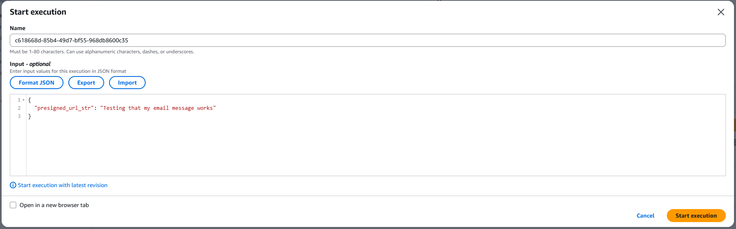Details about the execution are displayed.

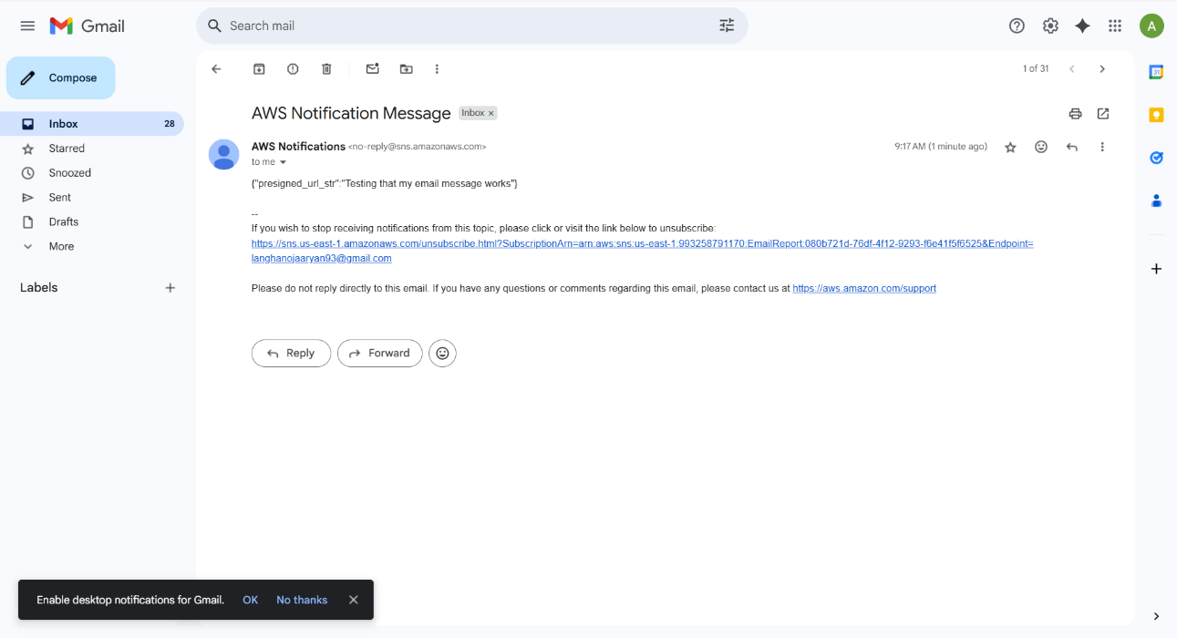

**Task 4: Creating a Lambda function to generate a presigned URL**

1. Create a sample *report.html* page.
   * Return to the VS Code IDE.
   * In the Environment window, choose File > New Text File.
   * In the new file that opens, paste in the following code.

* <output>Hello! This is some sample HTML.</output>
  + Choose File > Save.
    - Save the file under /home/ec2-user/environment directory.
  + 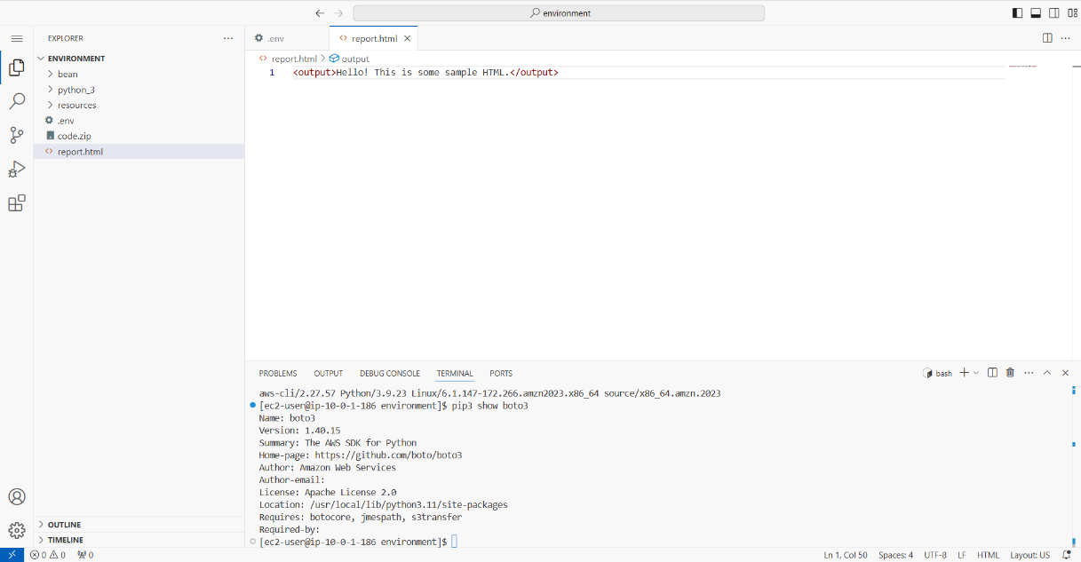Name the file report.html and choose Save.

1. Upload the sample report file to your S3 bucket, and observe the bucket policy settings.

* To upload the file to the S3 bucket and set the *cache-control max-age* value on the file to 0, run the following two commands in the VS Code IDE terminal:

**bucket=$(aws s3api list-buckets --query "Buckets[].Name" | grep s3bucket | tr -d ',' | sed -e 's/"//g' | xargs)**

**aws s3 cp report.html s3://$bucket/ --cache-control "max-age=0"**



* In a separate browser tab, navigate to the Amazon S3 console.
* Choose the link for the bucket that has *-s3bucket* in the name.
* Verify that the *report.html* file is now in the bucket.
* Choose the Permissions tab.
* Review the information in the Bucket policy section.

1. Test direct access to the sample report.

* In the Amazon S3 console, choose the **Objects** tab, and then choose **report.html**.
* Copy the **Object URL** and paste it into a new browser tab.
* You receive an *AccessDenied* error, as shown in the following image. This is expected because of the bucket policy details that you just observed.

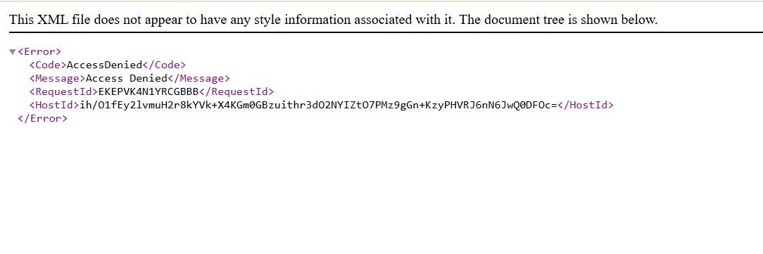

1. Create a presigned URL to access the report and test it.

* Return to the VS Code IDE.
* To generate a presigned URL that is valid for 30 seconds, run the following command:

**aws s3 presign s3://$bucket/report.html --expires-in 30**

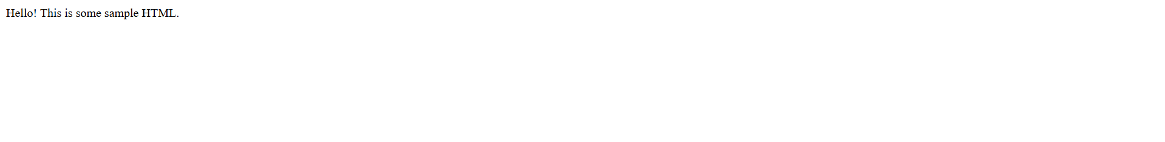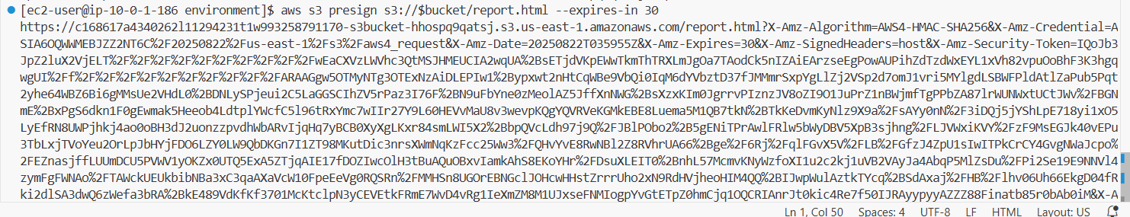

1. First, analyze the details of the IAM role that the Lambda functions in this lab will use.

* Navigate to the IAM console.
* Review the details of the *RoleForAllLambdas* IAM role.
  + In the left navigation pane, choose **Roles**.
  + In the search box under **Roles**, search for and choose the RoleForAllLambdas role.
  + On the **Permissions** tab, expand the **lambdaPolicyForAllLambdaSteps** policy, and choose **{} JSON**.
  + Notice that this role allows Amazon S3 and Amazon EC2 actions on all resources.
  + Choose the **Trust relationships** tab.
  + Notice that this role allows the Lambda service to assume this role (as indicated by the *lambda.amazonaws.com* service endpoint).

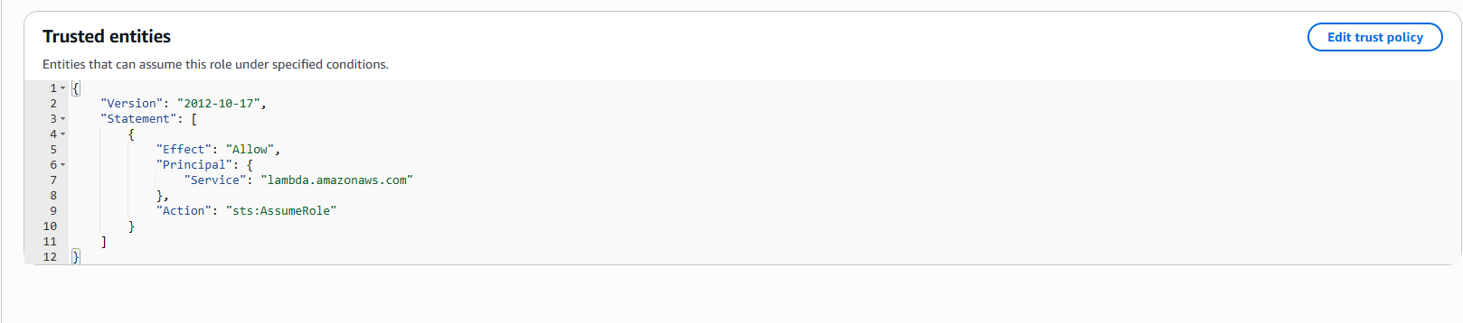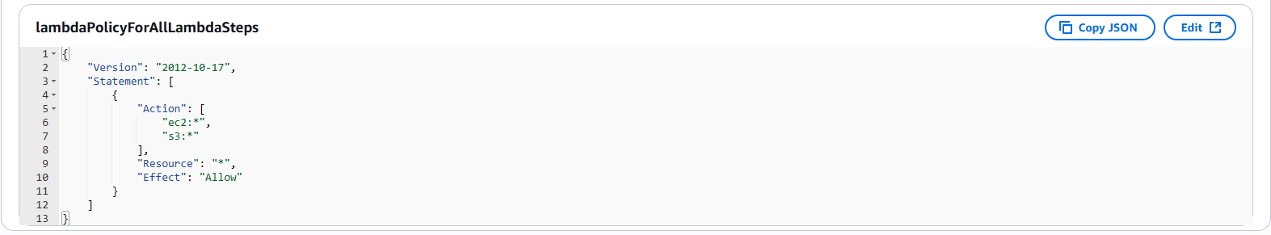

1. Create a Lambda function that will generate a presigned URL for the report.

* Navigate to the Lambda console.
* Verify that you are in the N. Virginia (us-east-1) Region.
* Choose **Create function** and configure the following:
  + Choose **Author from scratch**.
  + **Function name**: Enter GeneratePresignedURL
  + **Runtime**: Choose **Python 3.9**.
  + Expand the **Change default execution role** section.
  + **Execution role**: Choose **Use an existing role**.
  + **Existing role**: Choose **RoleForAllLambdas**.
* 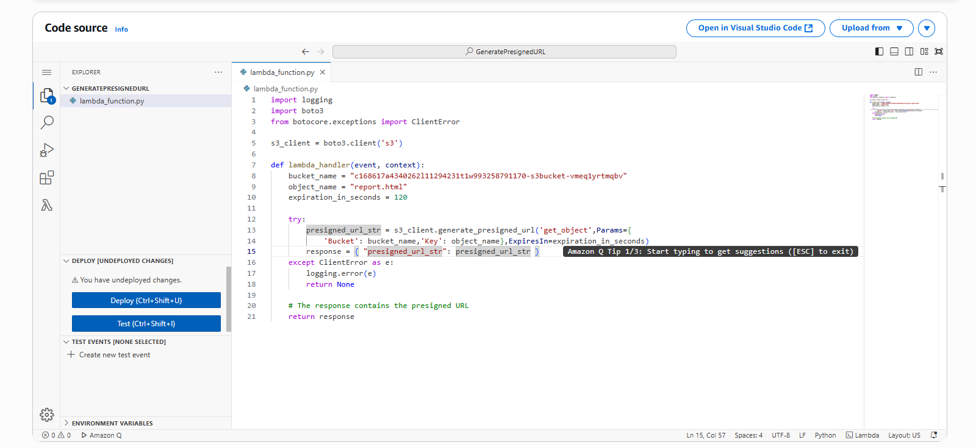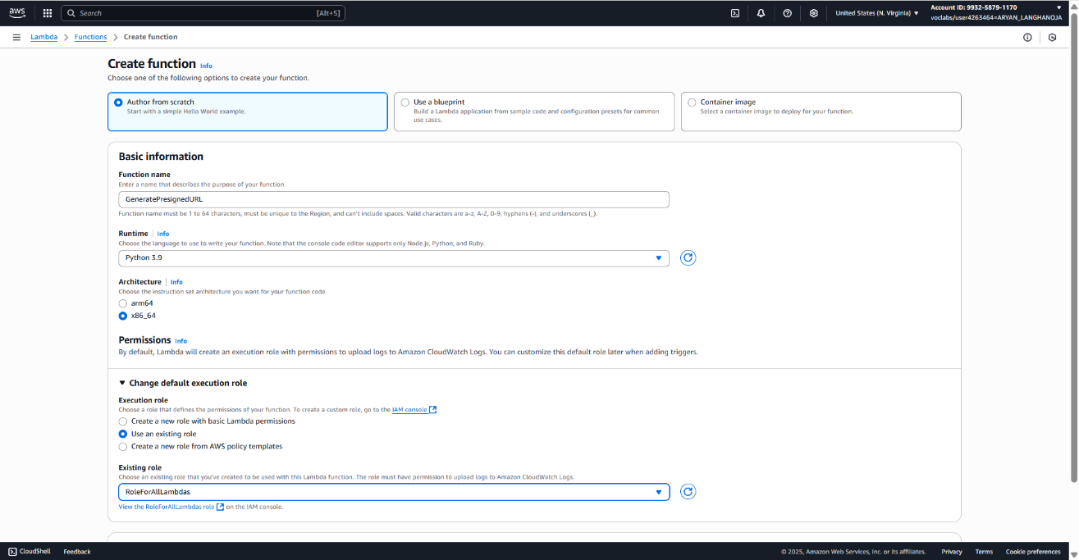At the bottom of the page, choose **Create function**.

1. Test the *GeneratePresignedURL* Lambda function.

* Choose Deploy.
* Choose Test, and for Event name, enter test1
* Choose Save, and then choose Test again.

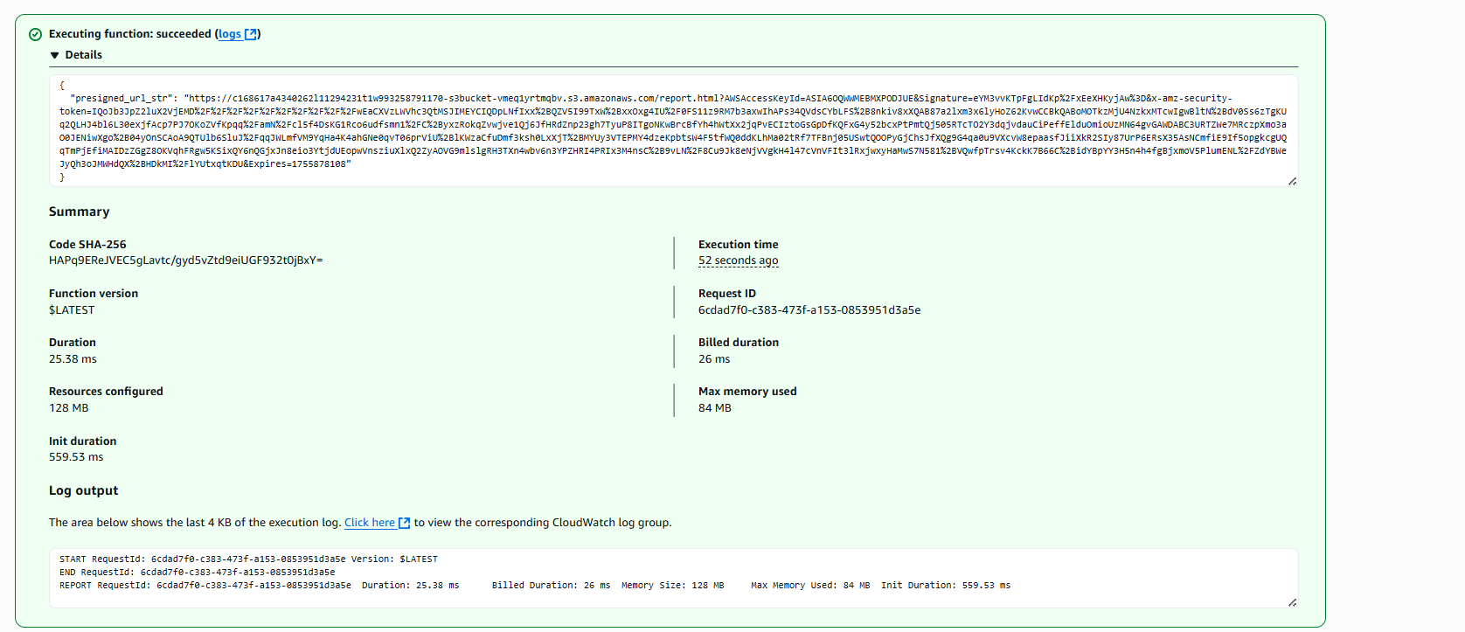The response includes a presigned URL, as shown in the following image.

* Copy the presigned URL and paste it in a new browser tab to confirm that it works.
* 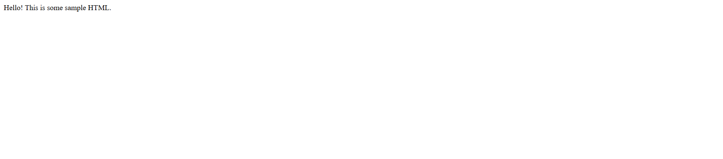If you load the page within 2 minutes, it will return the sample report contents, as shown in the following image.

1. Add the *GeneratePresignedURL* Lambda function to the Step Functions state machine.
   * Navigate to the Step Functions console.
   * Select **MyStateMachine**, and then choose **Edit**.
   * Search for Lambda
   * Drag the **AWS Lambda Invoke** object onto the canvas to the arrow just *above* the **SNS Publish** object, as shown in the following image

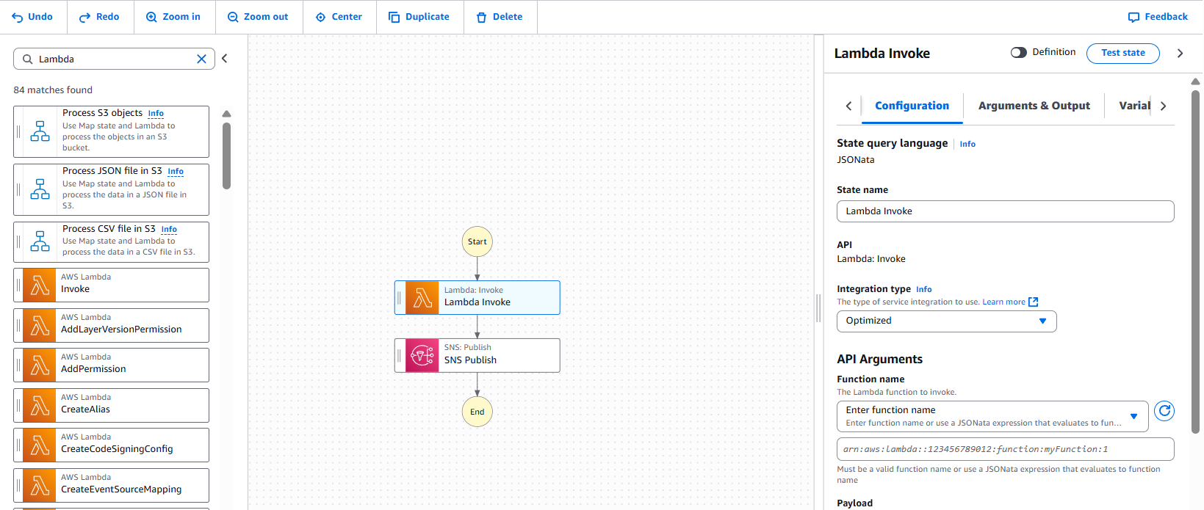

1. Configure the function details in the Lambda Invoke pane.
   * State name: Enter GeneratePresignedURL
   * Function name: Choose GeneratePresignedURL:$LATEST.
   * Payload: Choose No payload.
   * Next state: Choose SNS Publish.
   * Choose Save.

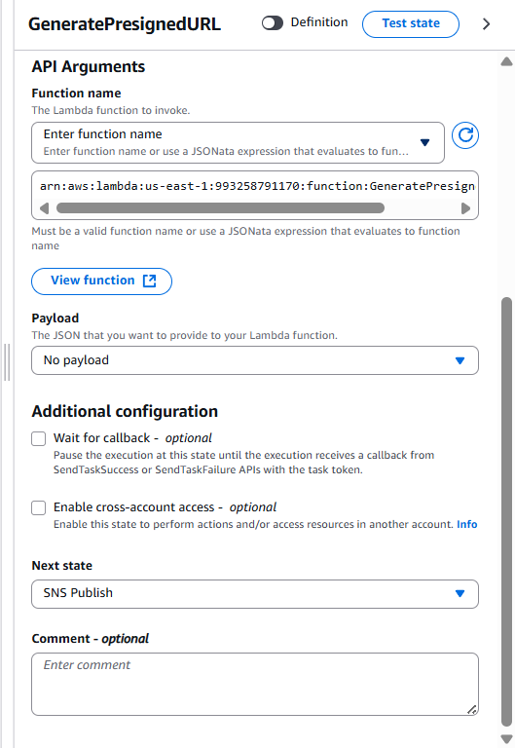

1. Test the update to the state machine.

* Choose **Execute**.
* In the code editor, delete the name-value pair that appears on line 2. The input code should only include the brackets, as shown in the following code block.

{

}

* Choose **Start execution**.
* To see the details, choose **Execution input and output**
* 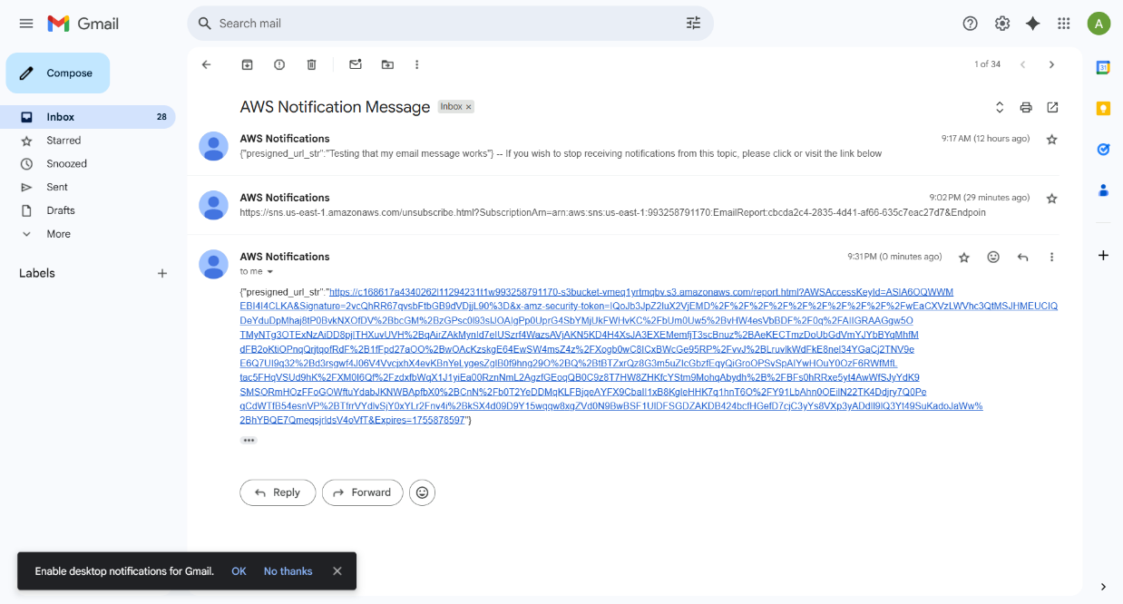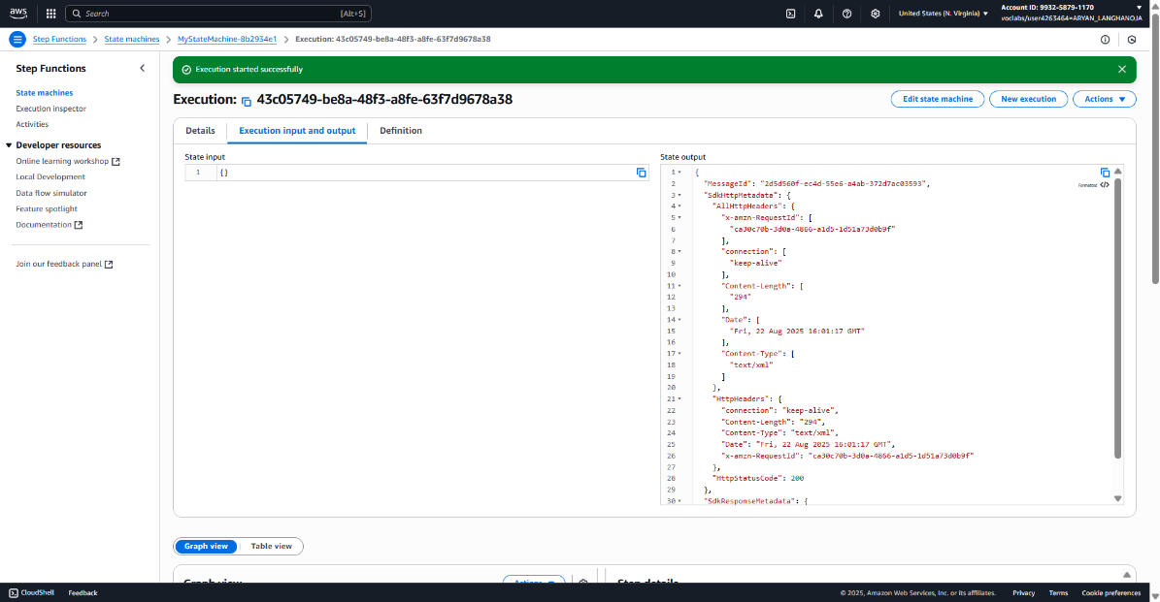Check your email for a notification, and choose the presigned URL in the message to verify that you can load the report.

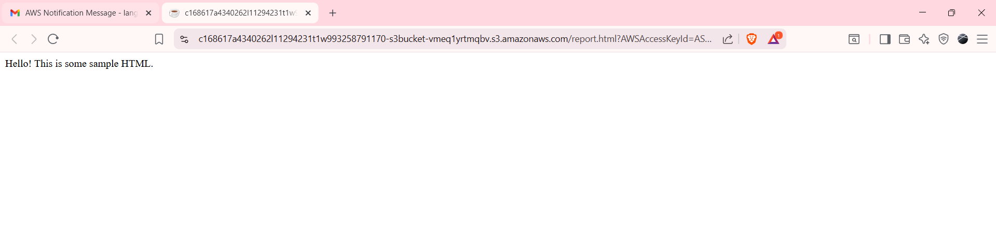

**Task 5: Configuring the REST API to invoke the state machine**

1. Configure API Gateway to invoke the Step Functions state machine.

* Navigate to the API Gateway console.
* Choose the link for ProductsApi.
* In the Resources pane, under /create_report, choose POST.
* Choose Integration Request and Edit. Configure the following:
  + Integration type: Choose AWS Service.
  + AWS Region: Choose us-east-1.
  + AWS Service: Choose Step Functions.
  + HTTP method: Choose POST.
  + Action Type: Choose Use action name.
  + Action: Enter StartExecution
  + Execution role: Paste the ARN that you copied in the previous step.
  + The ARN format is arn:aws:iam::account-number:role/RoleForAPIGWToTriggerStep, where account-number is your AWS account number.
  + Content Handling: Choose Passthrough.
* Request body passthrough: When there are no templates defined(recommended).
* Expand the Mapping Templates section.
* In the Content-Type field, enter application/json and then choose the check mark icon to confirm the entry.
* Choose Method request passthrough
* Replace the contents in Template body with the following code.

**{**

**"input": "$util.escapeJavaScript($input.json('$'))",**

**"stateMachineArn": "arn:aws:states:us-east-1:account-number:stateMachine:MyStateMachine"**

**}**

* In the code that you pasted in, replace account-number with your AWS account number.

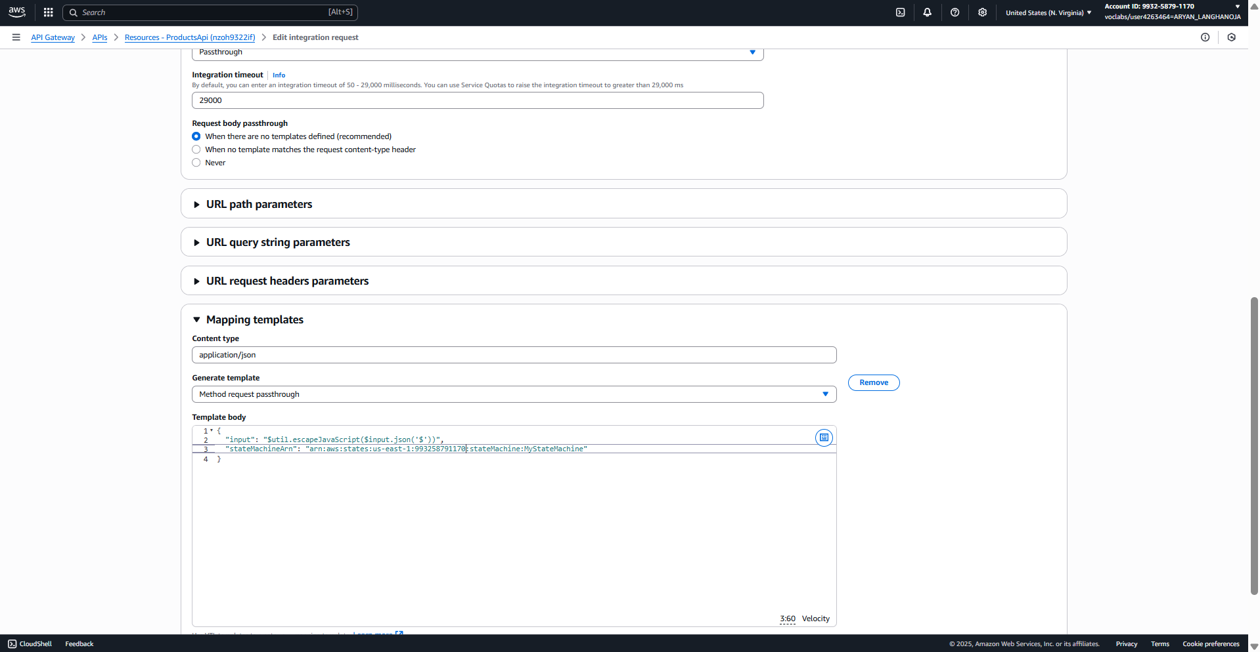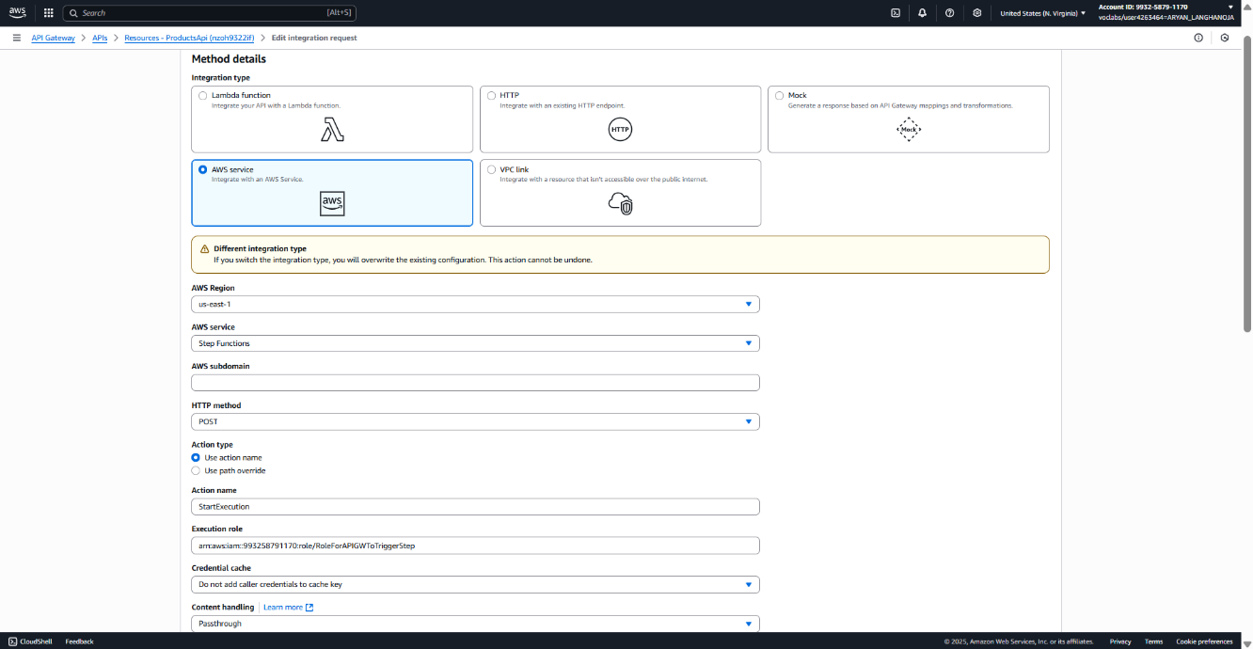

1. Test the modification to the API.

* Choose the Test tab.
* Keep all the default settings, and at the bottom of the page, choose Test.
* The Response Body section displays a JSON message similar to the following.

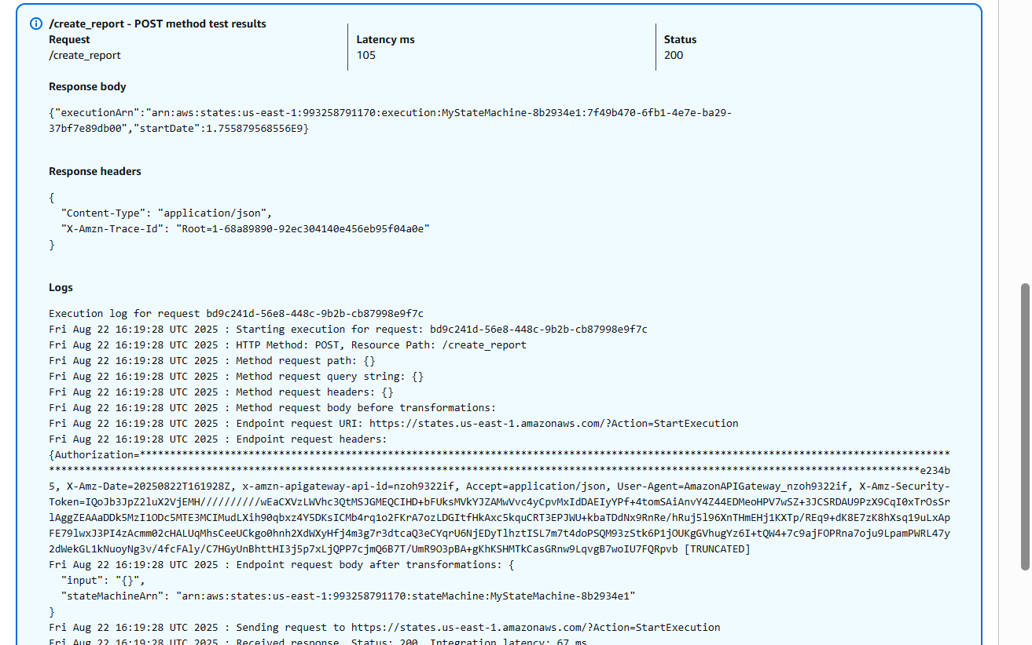

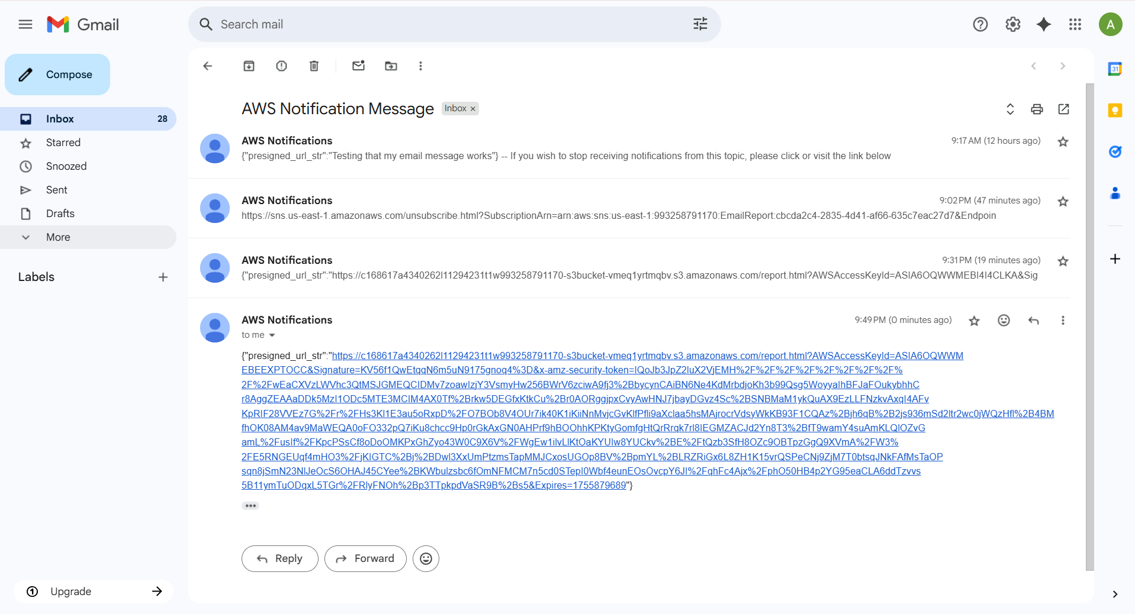

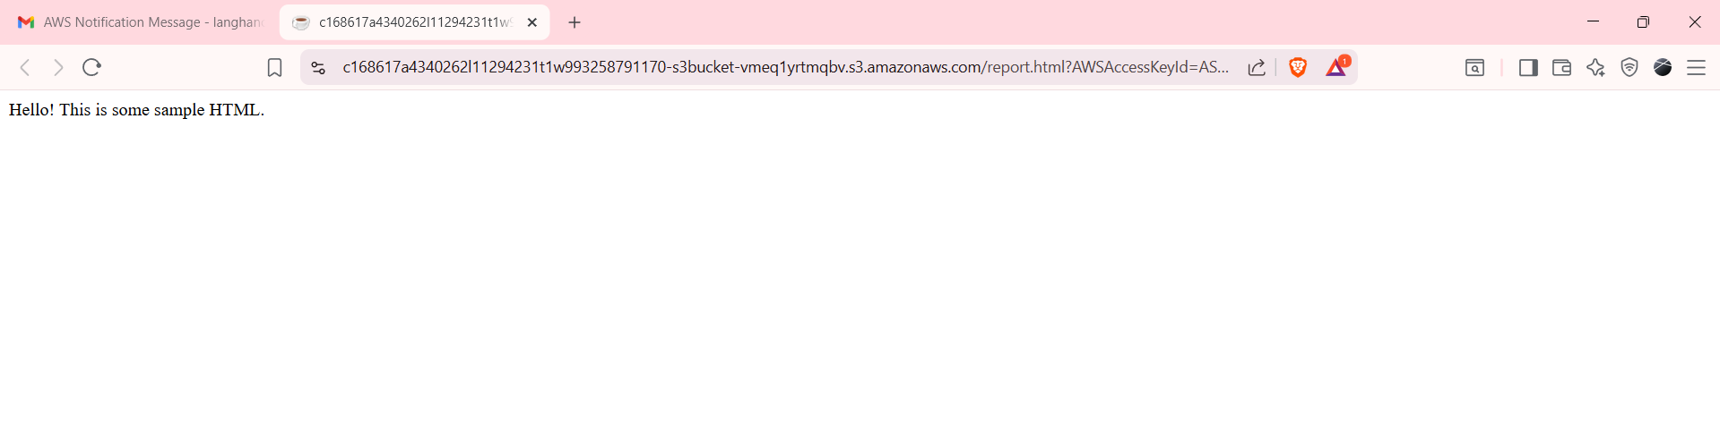

1. Test generating the presigned URL by using the Invoke URL endpoint.

* Return to the VS Code IDE.
* To generate a new presigned URL, run the following command. Replace *invoke-url* with the Invoke URL that you just copied.

**curl -X POST invoke-url/create_report**

* The full command looks similar to the following:

**curl -X POST https://nzoh9322if.execute-api.us-east-1.amazonaws.com/prod/create_report**

* The result includes a JSON response that contains executionArn and startDate name-value pairs.



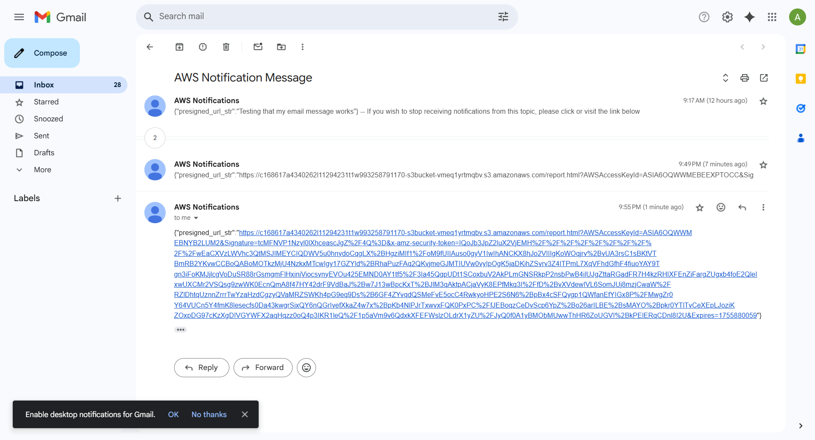

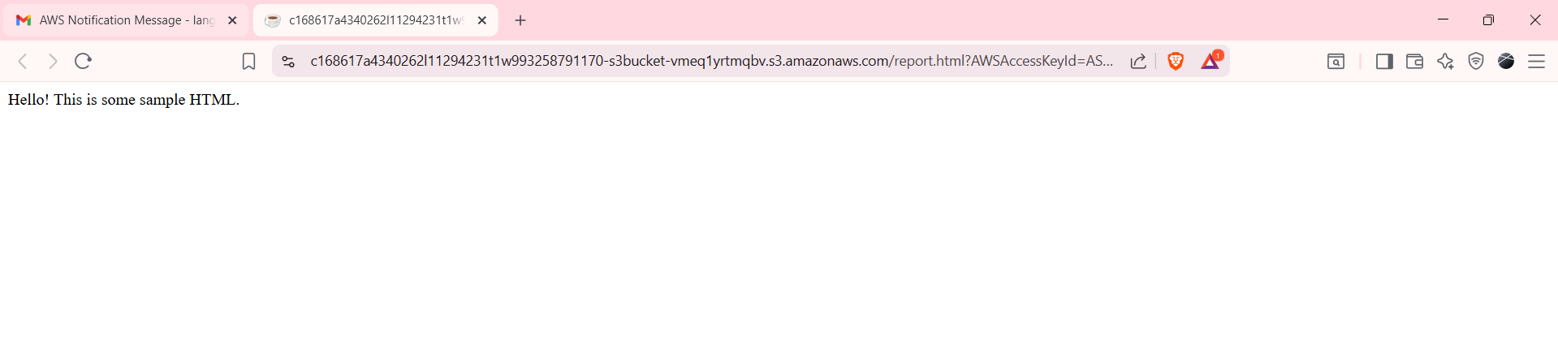

**Task 6: Configuring a Lambda function to generate an HTML report**

1. Create a Lambda function that will generate an HTML report with data extracted from a JSON object.

* Navigate to the Lambda console.
* Verify that you are in the N. Virginia (us-east-1) Region.
* Choose **Create function** and configure the following:
  + Choose **Author from scratch**.
  + **Function name**: Enter generateHTML
  + **Runtime**: Choose **Node.js 20.x**.
  + Expand the **Change default execution role** section.
  + **Execution role**: Choose **Use an existing role**.
  + **Existing role**: Choose **RoleForAllLambdas**.
* At the bottom of the page, choose **Create function**.
* Choose the **Configuration** tab, and then choose **Edit** in the **General configuration** section.
* Adjust the timeout to 2 minutes, and then choose **Save**.
* Choose the **Code** tab, and in the **Code source** section, replace the existing code with the following.

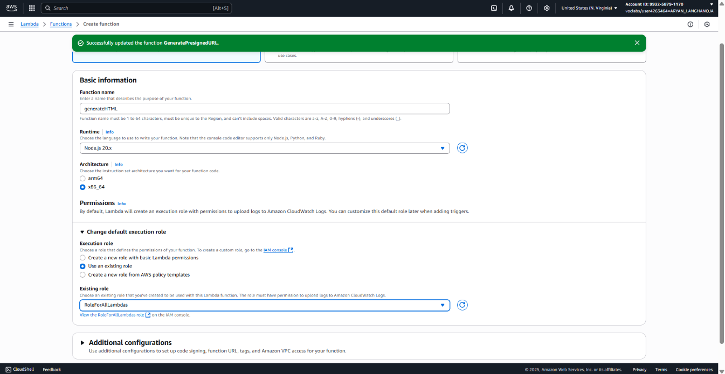

1. Test the new *generateHTML* Lambda function.

* Choose **Deploy**.
* Choose the down arrow next to **Test**, and choose **Configure test event**.
* For **Event name**, enter test2
* Paste the following code in as the input (replace the existing lines):

{

"my_json_arr": [

{

"suppliers_id_int": 1,

"supplier_name_str": "AnyCompany coffee suppliers",

"supplier_address_str": "123 Any Street",

"bean_info_obj_arr": [

{

"type_str": "Arabica",

"product_name_str": "Best bean",

"quantity_int": "300",

"price_int_str": "18.00"

},

{

"type_str": "Robusta",

"product_name_str": "Great bean",

"quantity_int": "100",

"price_int_str": "12.00"

}

]

},

{

"suppliers_id_int": 2,

"supplier_name_str": "Central Example Corp. coffee",

"supplier_address_str": "100 Main Street",

"bean_info_obj_arr": [

{

"type_str": "Robusta",

"product_name_str": "Top bean",

"quantity_int": "200",

"price_int_str": "10.00"

},

{

"type_str": "Liberica",

"product_name_str": "Better bean",

"quantity_int": "150",

"price_int_str": "14.00"

}

]

}

]

}

* Choose **Save**, and then choose **Test** again.
* The response includes the following JSON message.

{

"msg_str": “Report published to S3”

}

**Task 7: Adding the GenerateHTML function to the state machine**

1. Edit the Step Functions state machine to add a parallel state.

* Navigate to the Step Functions console.
* In the left navigation pane, choose State machines.
* Select MyStateMachine, and then choose Edit.
* Choose the Flow tab in the left pane.
* Drag the Parallel object onto the canvas, just above the Lambda Invoke object.
* Drag the GeneratePresignedURL object to the box labeled *Drop state here* on the right, under the Parallel state object, as shown in the following image.

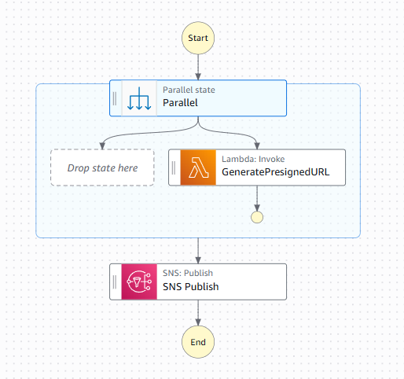

1. Add the *GenerateHTML* function to the state machine, and configure it.
   * Choose the Actions tab in the left pane.
   * Search for Lambda
   * Drag the AWS Lambda Invoke object onto the canvas to the box labeled *Drop state here* on the left, under the Parallel state object.
   * Choose the new Lambda Invoke object and configure the following function details in the Lambda Invoke pane.
     + State name: Enter generateHTML
     + Function name: Choose generateHTML:$LATEST.
     + Payload: Choose Use state input as payload.
     + Next state: Choose Go to end.

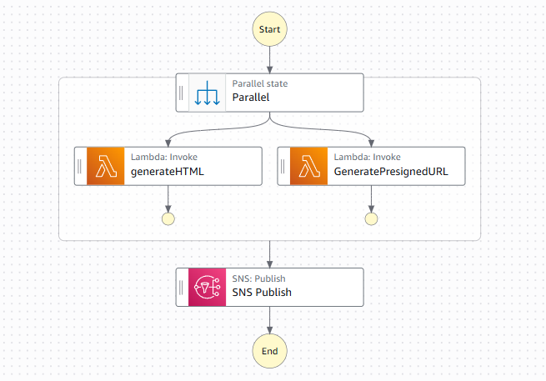

1. Configure the Parallel state card details, and then save the changes.
   * On the canvas, choose the Parallel state object.
   * For **State name**, enter Process Report
   * 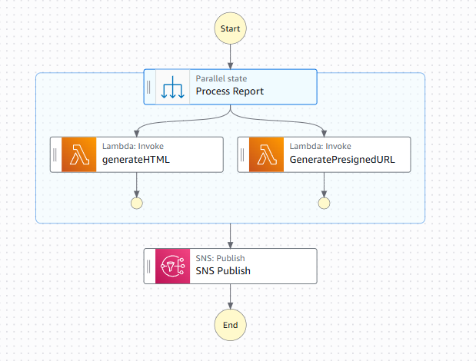Choose **Save**.
2. Test the updated state machine.
3. Choose Execute and configure the following:

In the code editor, replace the existing JSON code with the following.

**{**

**"my_json_arr": [**

**{**

**"suppliers_id_int": 1,**

**"supplier_name_str": "Dave coffee suppliers",**

**"supplier_address_str": "123 Any Street",**

**"bean_info_obj_arr": [**

**{**

**"type_str": "Arabica",**

**"product_name_str": "Best bean",**

**"quantity_int": "300",**

**"price_int_str": "18.00"**

**},**

**{**

**"type_str": "Robusta",**

**"product_name_str": "Great bean",**

**"quantity_int": "100",**

**"price_int_str": "12.00"**

**}**

**]**

**},{**

**"suppliers_id_int": 2,**

**"supplier_name_str": "Central Example Corp. coffee",**

**"supplier_address_str": "100 Main Street",**

**"bean_info_obj_arr": [**

**{**

**"type_str": "Robusta",**

**"product_name_str": "Top bean",**

**"quantity_int": "200",**

**"price_int_str": "10.00"**

**},**

**{**

**"type_str": "Liberica",**

**"product_name_str": "Better bean",**

**"quantity_int": "150",**

**"price_int_str": "14.00"**

**}**

**]**

**}**

**]**

**}**

Notice that the input now consists of an array.

* Choose Start execution.
* To see the details, choose Execution input and output.
* Check your email for a new notification with a presigned URL.

The email now includes two name-value pairs, in the following format, which is truncated for brevity:

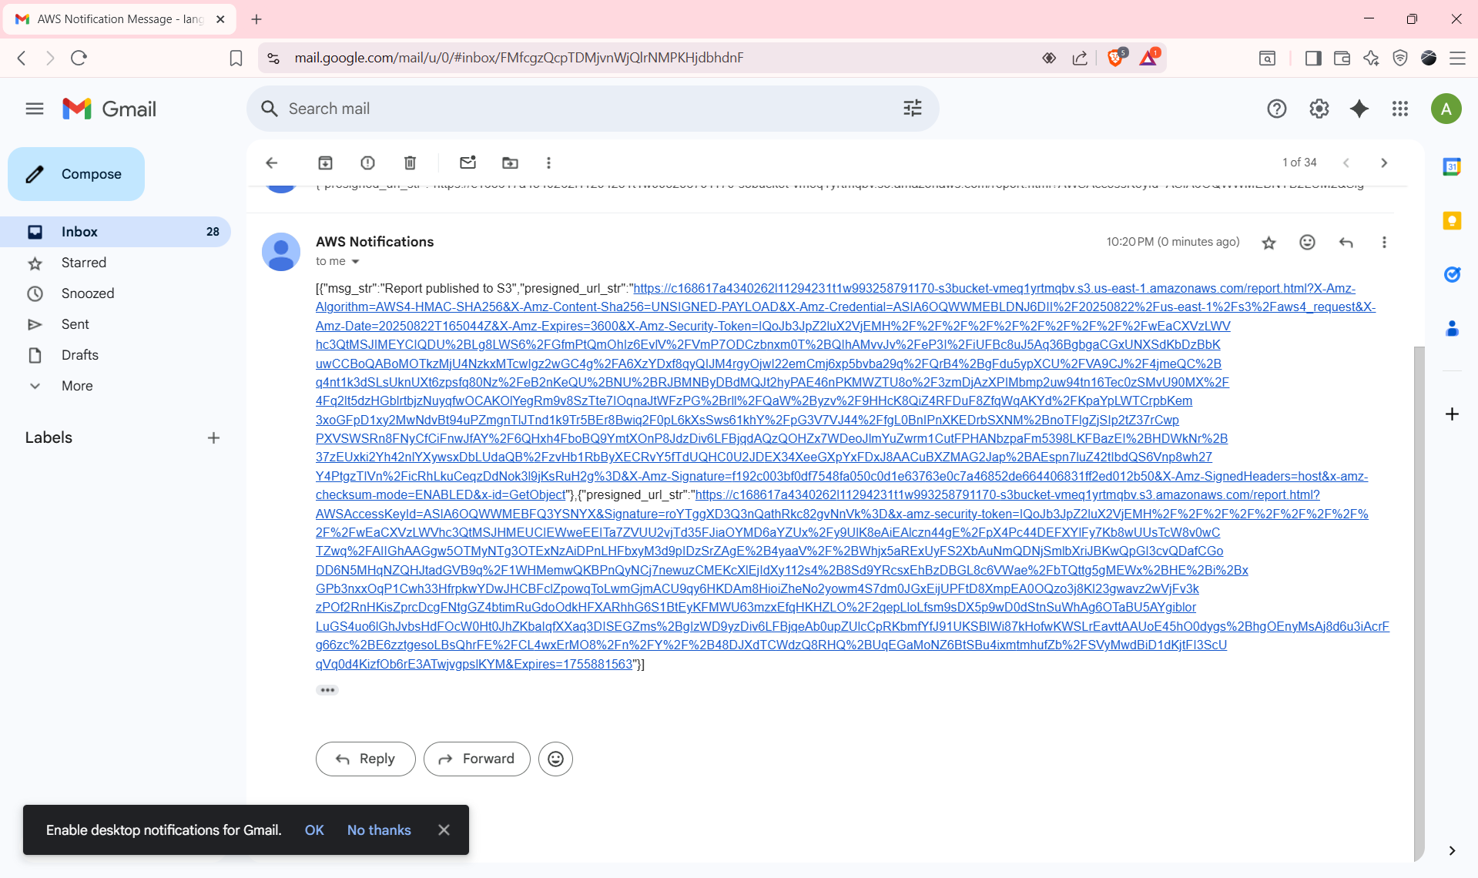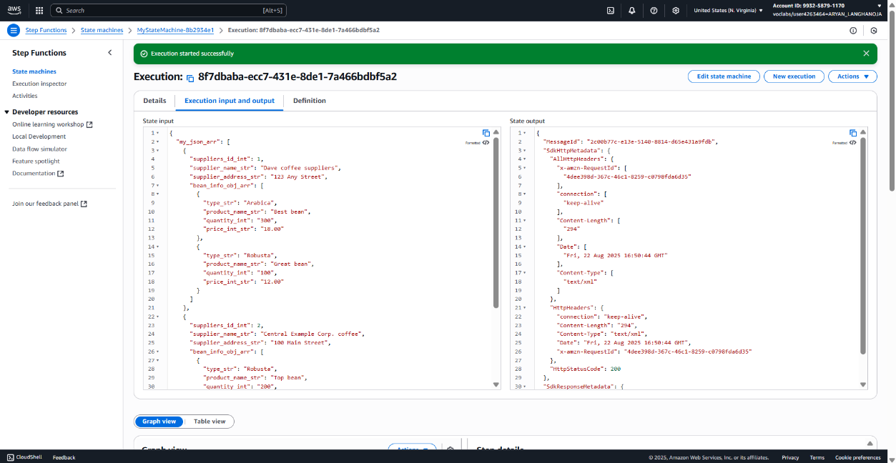**[{"msg_str":"Report published to S3"},{"presigned_url_str":"https://...&Expires=..."}]**

**Task 8: Creating a Lambda function to retrieve supplier records**

1. Create a Lambda function to query the database.

* Navigate to the Lambda console.
* Verify that you are in the N. Virginia (us-east-1) Region.
* Choose **Create function** and configure the following:
  + Choose **Author from scratch**.
  + **Function name**: Enter generateReportData
  + **Runtime**: Choose **Node.js 20.x**.
  + Expand the **Change default execution role** section.
  + **Execution role**: Choose **Use an existing role**.
  + **Existing role**: Choose **RoleForAllLambdas**.
* At the bottom of the page, choose **Create function**.
* Choose the **Configuration** tab, and then choose **Edit**.
* Set the timeout for this function to 1 minute and save the change.

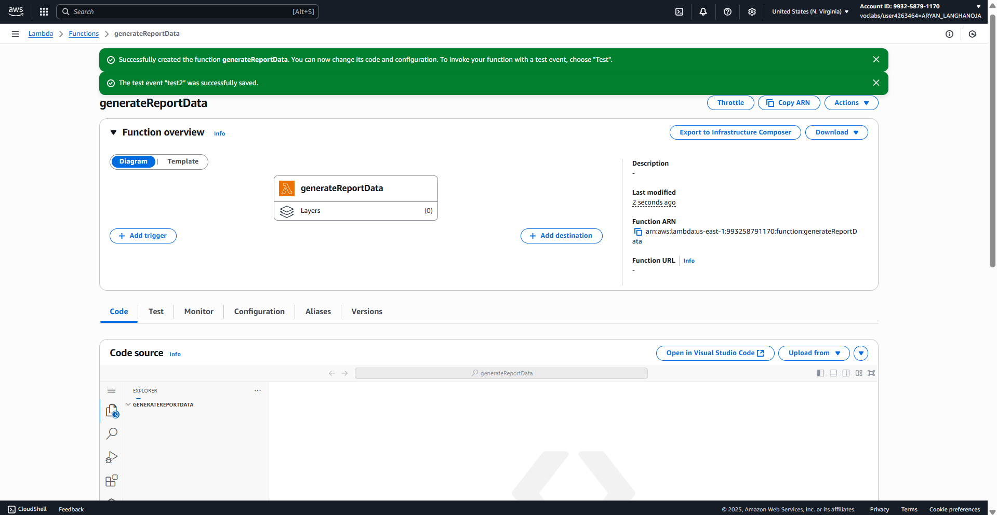

1. Create an index.js file.
   * Return to the VS Code IDE.
   * In the **Environment** window, open the context (right-click) menu for the root directory, and then choose **New Folder**.
   * Name the folder lambda
   * Inside the **lambda** folder, create a new file named index.js
   * Paste the following code into the file.

import { S3Client } from '@aws-sdk/client-s3';

import mysql from 'mysql2/promise';

const s3Client = new S3Client({ region: "us-east-1" });

export const handler = async (event, context) => {

   try {

       // Establish MySQL connection

       const connection = await mysql.createConnection({

           host: 'DB-ENDPOINT',

           user: 'nodeapp',

           password: 'coffee',

           database: 'COFFEE'

      });

       // Query suppliers

       const [suppliers] = await connection.query('SELECT * FROM suppliers');

       // Query beans

       const [beans] = await connection.query('SELECT * FROM beans');

       // Close connection

       await connection.end();

       // Merge data

       const mergedData = mergeData(suppliers, beans);

       // Return the merged result

       return {

           statusCode: 200,

           body: JSON.stringify({

               my_json_arr: mergedData

          })

      };

  } catch (err) {

       console.error("Error executing query:", err);

       return {

           statusCode: 500,

           body: JSON.stringify({

               error: 'Failed to retrieve data from MySQL',

               details: err.message

          })

      };

  }

};

// Function to merge suppliers and beans data

function mergeData(suppliers_arr, beans_arr) {

   const fine_tunes_data_arr = [];

   for (const supplier of suppliers_arr) {

       const o = {

           suppliers_id_int: supplier.id,

           supplier_name_str: supplier.name,

           supplier_address_str: supplier.address,

           supplier_phone_str: supplier.phone,

           bean_info_obj_arr: []

      };

       for (const bean of beans_arr) {

           if (supplier.id === bean.supplier_id) {

               const b = {

                   type_str: bean.type,

                   product_name_str: bean.product_name,

                   quantity_int: bean.quantity

              };

               o.bean_info_obj_arr.push(b);

          }

      }

       fine_tunes_data_arr.push(o);

  }

   return fine_tunes_data_arr;

}

* + Retrieve the value for the database endpoint:
    1. In a new browser tab, navigate to the Amazon RDS console.
    2. Choose **Databases**, and then choose the **supplierdb** link.
    3. Copy the **Writer - Endpoint** value for the database. The value displays in the **Connectivity & security** section.
  + Return to the VS Code IDE.
  + In the *index.js* file, replace the DB-ENDPOINT placeholder, which appears on line 9, with the database endpoint that you just copied. Be sure to keep the single quotes around it.
  + Save the file.

1. Create a package.json file.
   * In the VS Code IDE, create a new file named package.json in the **lambda** folder.
   * Paste the following code into the new file, and save the changes.

{

 "dependencies": {

   "mysql2": "*",

   "@aws-sdk/client-s3": "*"

},

 "type": "module"

}

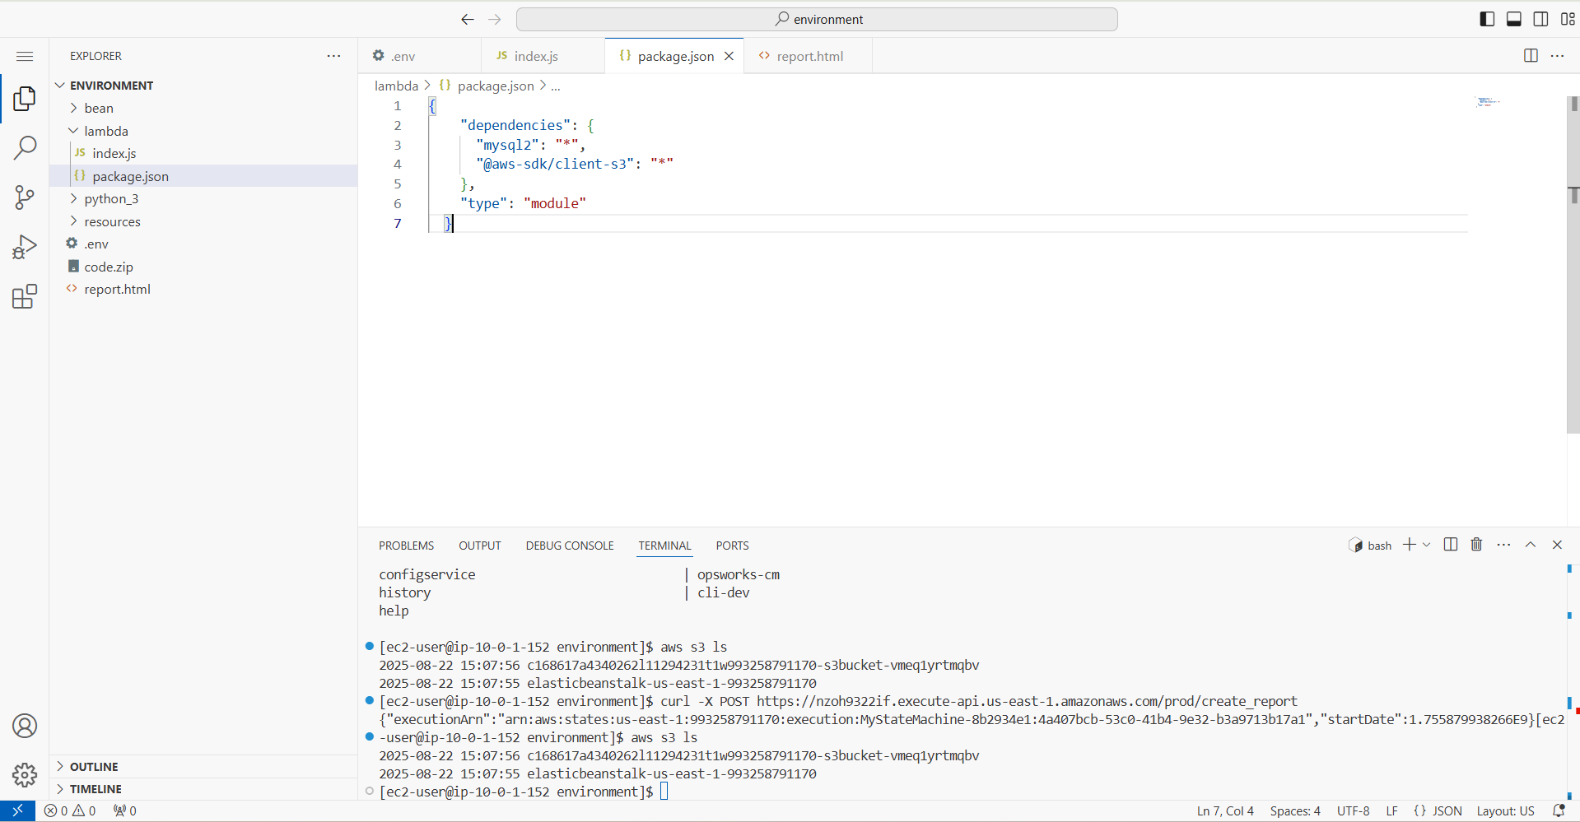

1. Generate the .zip package.
   * To install npm and then create a .zip archive file named *lambda.zip* that contains the two files that you just created, as well as the node modules, run the following commands in the VS Code IDE terminal.

cd ~/environment/lambda

npm install

zip -r ../lambda.zip *

* + Download the resulting *lambda.zip* file from the VS Code IDE to your computer:
    1. In the **Environment** window, open the context (right-click) menu for the **lambda.zip** file, and then choose **Download**.
    2. When prompted, save the file.

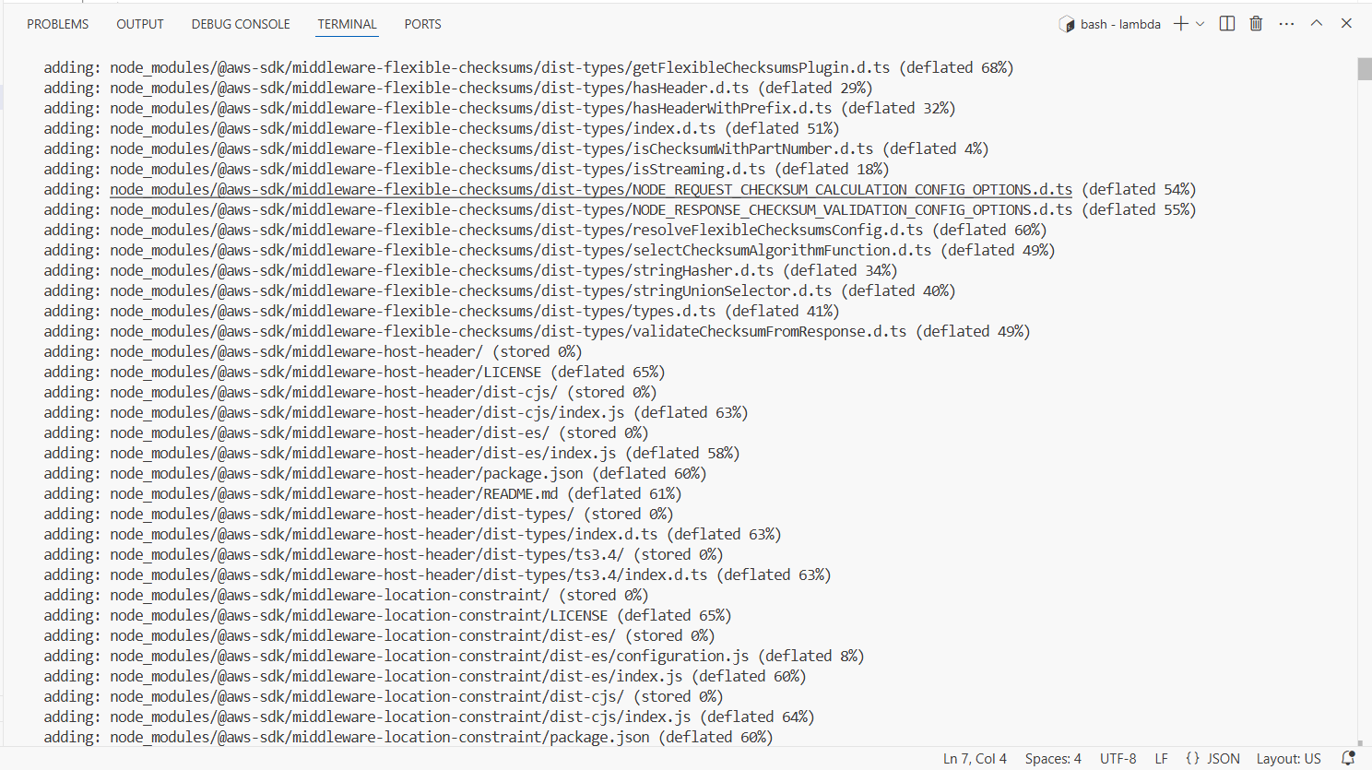

1. Finish configuring the *generateReportData* Lambda function.

* Return to the Lambda console, where you were configuring the *generateReportData* function.
* Choose the **Code** tab.
* In the **Code source** section, choose **Upload from**, and then choose **.zip file**.
* Choose **Upload**, and then browse to and open the *lambda.zip* file that you just saved to your computer.
* Choose **Save**.
* Verify that the **Environment** panel in the **Code source** section now shows that the files contained in the .zip file were uploaded and extracted successfully, as shown in the following image.

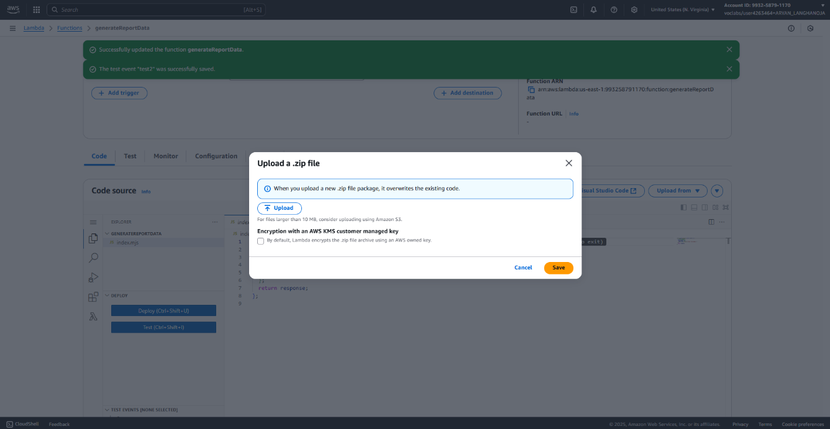

1. Configure the *generateReportData* Lambda function to access resources in the virtual private cloud (VPC).

* In the Lambda console, choose the Configuration tab, and then choose VPC.
* In the VPC section, choose Edit.
* Choose the VPC named Lab IDE VPC.
* For Subnets, choose *both* us-east-1a and us-east-1b.
* For Security groups, choose the security group that has ClusterSecurityGroup in the name.
* When you are satisfied that your settings are correct, choose Save.
* 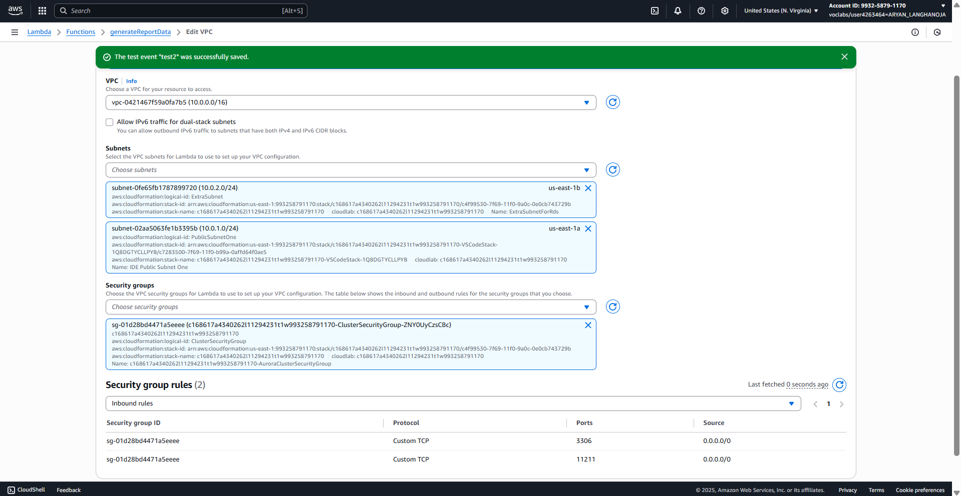A message that says *Updating the function generateReportData* appears in a blue bar at the top of the console.

1. Test the *generateReportData* function with the new VPC settings applied.

* In the **Lambda** console, return to the **Code** tab.
* Choose the down arrow next to **Test**, and choose **Configure test event**.
* Choose **Create new test event**.
* For **Event name**, enter vpcAdjusted
* Choose **Save**, and then choose **Test** again.
* The response includes all eight records from the Amazon RDS database.

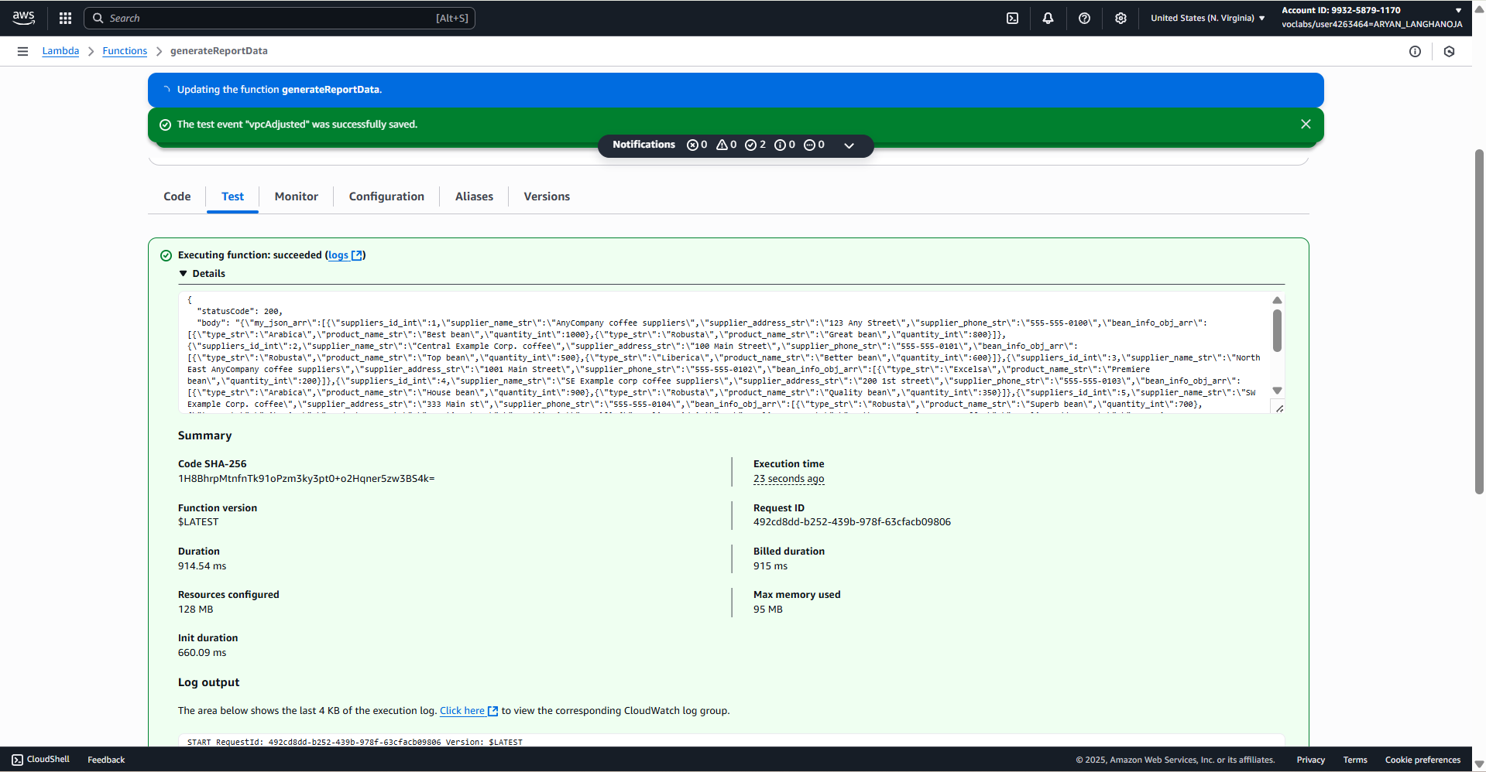

**Task 9: Adding the generateReportData function to the state machine**

1. Add the *generateReportData* function to the state machine.
   * Navigate to the Step Functions console.
   * Select MyStateMachine, and then choose Edit.
   * Search for Lambda
   * Drag an AWS Lambda Invoke object onto the canvas, *above* the Process Report parallel state object.
2. Configure the function details in the Lambda Invoke pane.
   * State name: Enter getRealData
   * Function name: Choose generateReportData:$LATEST.
   * Payload: Choose No payload.
   * Choose Save.

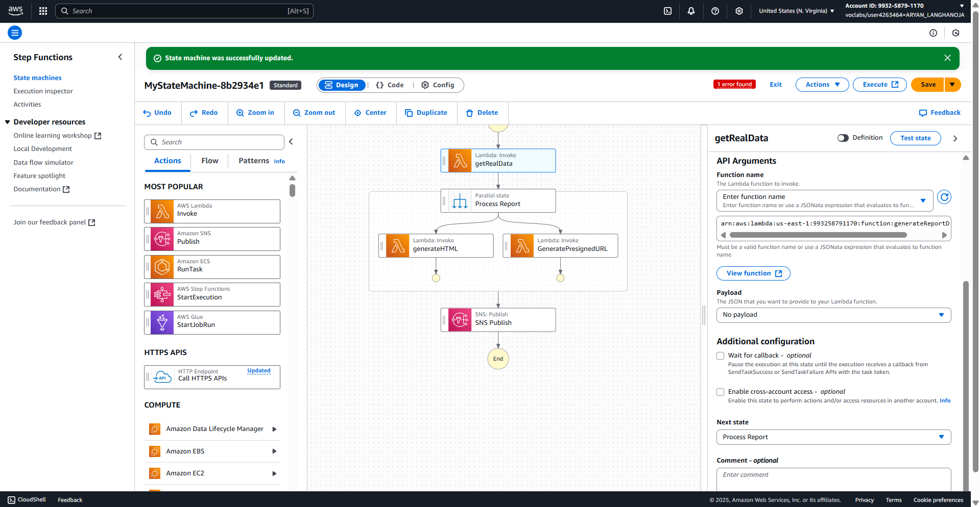

1. Test the completed state machine by using the Step Functions console.

* Choose Execute and configure the following:
  + In the code editor, delete the name-value pair that appears on line 2. The input code should only include the brackets, as shown in the following code block.

{

}

* Choose Start execution.
* Check your email for a notification, and choose the presigned URL in the message to verify that you can load the report.

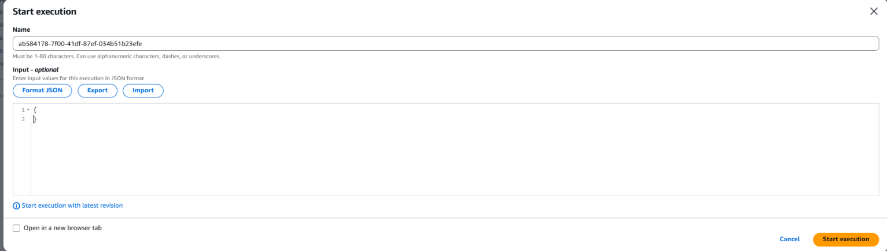

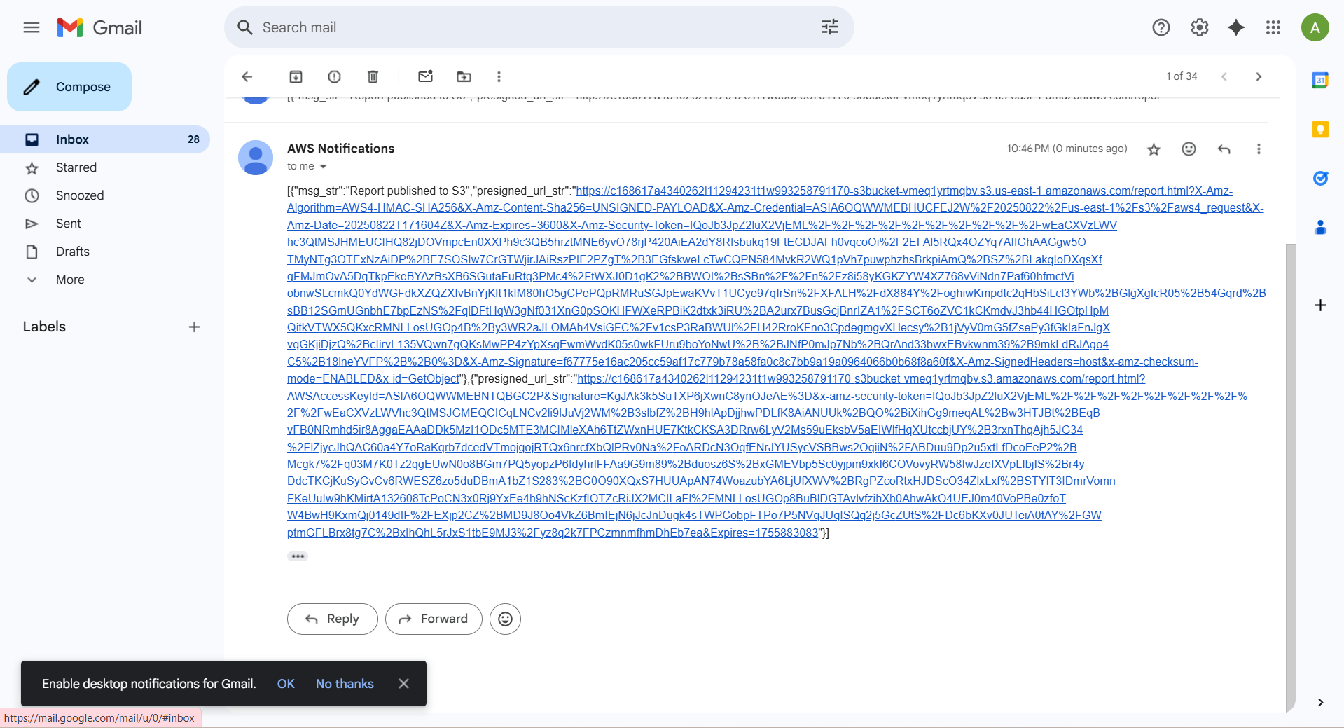

1. Test the *create_report* REST API endpoint.

* Navigate to the API Gateway console.
* Choose the link for **ProductsApi**.
* In the navigation pane, choose **Stages**.
* In the **Resources** pane, choose **prod**.
* Copy the **Invoke URL**.
* Return to the VS Code IDE.
* In the terminal, enter curl -X POST but *do not run the command yet*.
* Add a space and then paste in the invoke URL that you just copied. *Do not run the command yet.*
* Add /create_report to the end of the invoke URL.
  + The resulting command looks similar to the following, where *unique-string* is some unique string:

curl -X POST https://unique-string.execute-api.us-east-1.amazonaws.com/prod/create_report

* Run the command.
  + The response looks similar to the following.

{

"executionArn":"arn:aws:states:us-east-1:221264991720:express:MyStateMachine:453b6f3d-ab5a-4ac3-a2d2-0d74f728a740:243fcd35-ff80-4f8d-bc2a-b0580391277e","startDate":1.632788164722E9

}

* Check your email for a notification, and load the report using the presigned URL contained in the email.

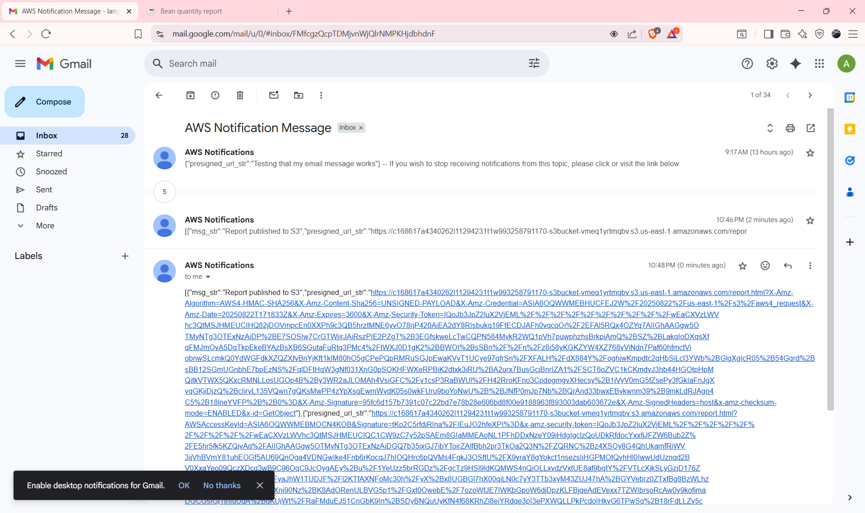

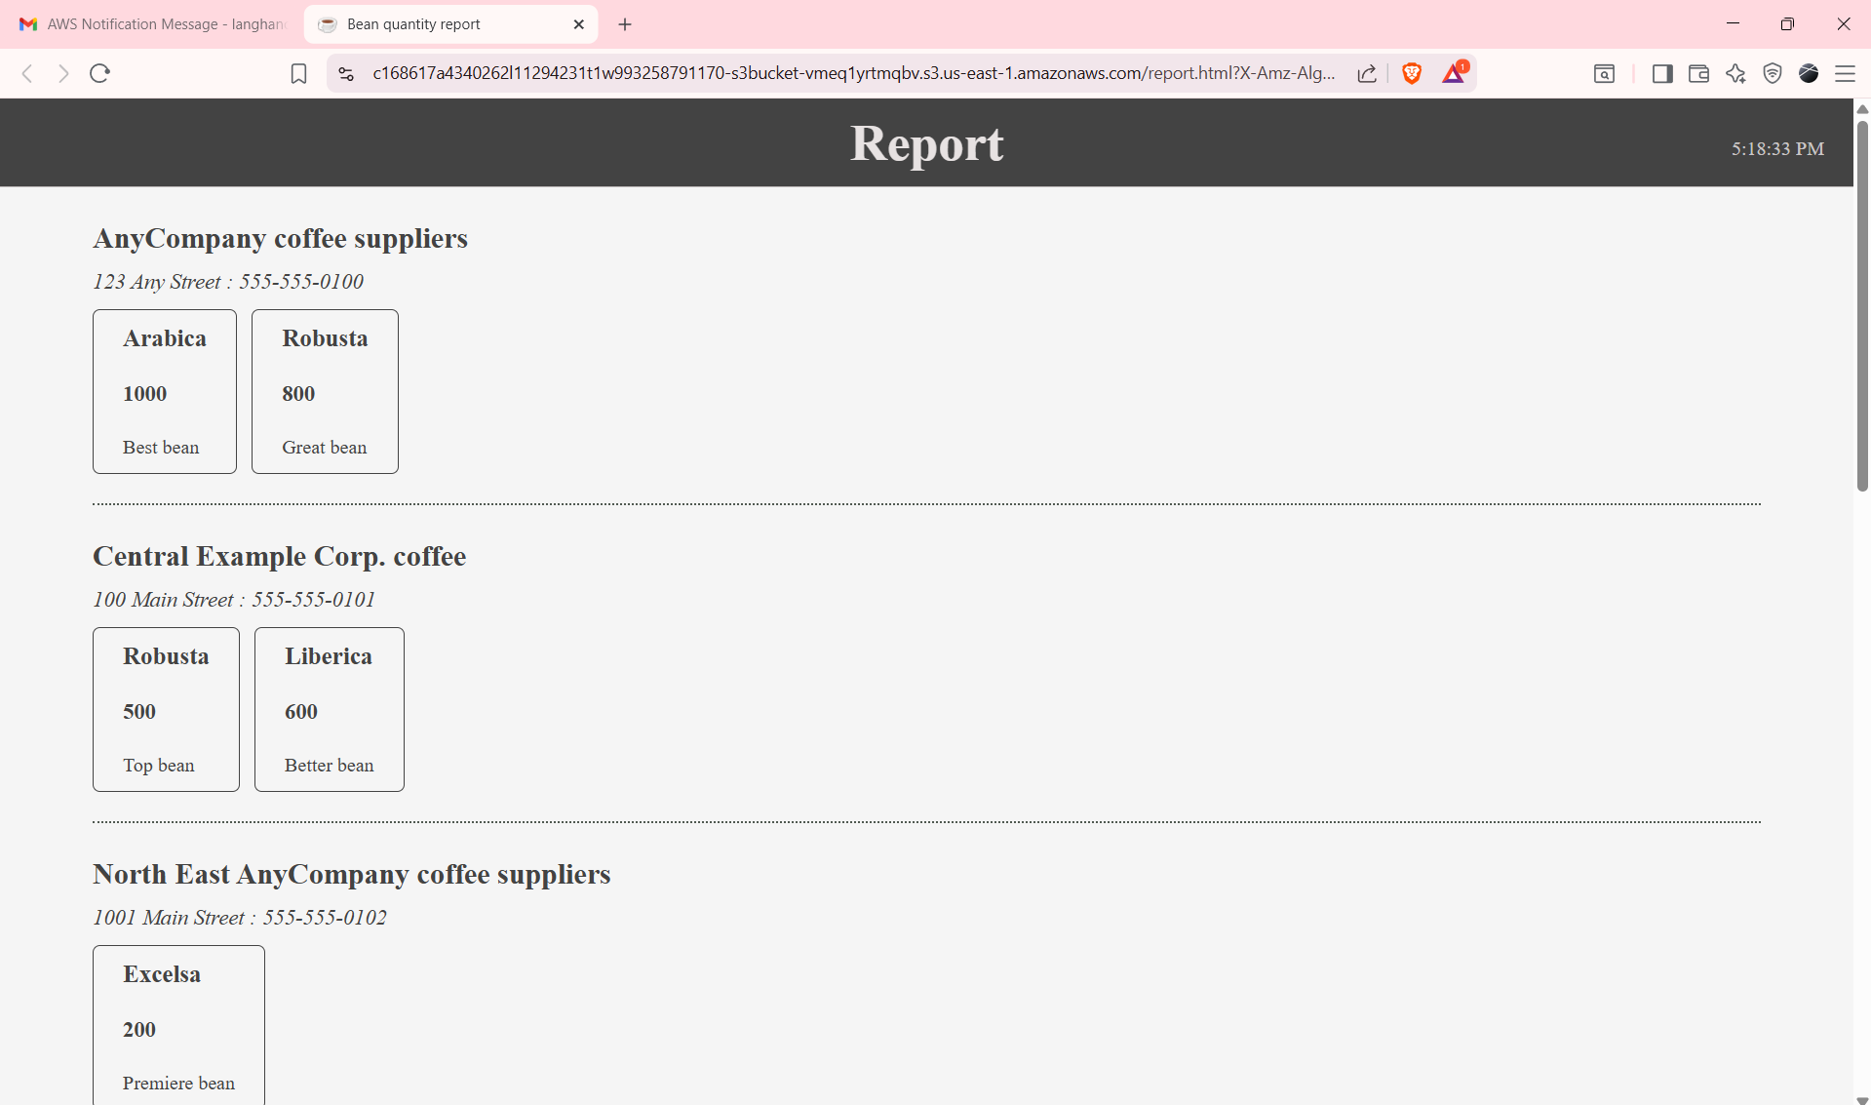

**Conclusion:-**

* I connected to the VS Code IDE using the provided LabIDEURL and LabIDEPassword.
* I downloaded the lab resources into the environment using:

**wget https://aws-tc-largeobjects.s3.us-west-2.amazonaws.com/CUR-TF-200-ACCDEV-2-91558/11-lab-step/code.zip -P /home/ec2-user/environment**

**unzip code.zip**

* I upgraded the AWS CLI by giving permissions and executing the setup script:

**chmod +x ./resources/setup.sh && ./resources/setup.sh**

* I verified the AWS CLI version and Python SDK installation:

**aws --version**

**pip3 show boto3**

* I checked the café website by opening index.html from the S3 bucket in the browser.
* I configured an SNS topic named EmailReport and subscribed via email.
* I confirmed the subscription and tested notifications by publishing a message.
* I created an IAM role (RoleForStepToCreateAReport) for Step Functions.
* I designed a state machine in Step Functions with SNS Publish as the first state and executed it with test JSON input:

**{**

**"presigned_url_str": "Testing that my email message works"**

**}**

* I created a sample HTML report (report.html), uploaded it to the S3 bucket, and tested object access:

**bucket=$(aws s3api list-buckets --query "Buckets[].Name" | grep s3bucket | tr -d ',' | sed -e 's/"//g' | xargs)**

**aws s3 cp report.html s3://$bucket/ --cache-control "max-age=0"**

**aws s3 presign s3://$bucket/report.html --expires-in 30**

* I created and tested the GeneratePresignedURL Lambda function in Python 3.9, verified its execution, and integrated it into the Step Functions state machine.
* I created another Lambda function (generateHTML) in Node.js 20.x to generate an HTML report from a JSON object and tested it with sample supplier/bean JSON data.
* I updated the Step Functions state machine to include a Parallel State with both GeneratePresignedURL and generateHTML Lambda functions running in parallel.
* I created another Lambda function (generateReportData) in Node.js 20.x to fetch supplier records from the RDS database using mysql2.
* I packaged the function:

**cd ~/environment/lambda**

**npm install**

**zip -r ../lambda.zip \***

* I uploaded lambda.zip to AWS Lambda, configured it with VPC and subnets, and successfully tested database queries.
* I integrated generateReportData into the state machine before the parallel tasks.
* I tested the final state machine execution with empty {} input and successfully received a report email containing both generated HTML and a presigned URL.
* I configured API Gateway with /create_report endpoint mapped to Step Functions StartExecution action.
* I tested the REST API with:

**curl -X POST https://nzoh9322if.execute-api.us-east-1.amazonaws.com/prod/create_report**

* I received execution details in JSON and verified the email notification with a working report link.
* Successfully orchestrated **serverless functions** with **AWS Step Functions**, **Lambda**, **SNS**, **S3**, **RDS**, and **API Gateway**.
* Automated a workflow where a report is generated dynamically, stored securely, and shared via presigned URL through an email notification.

**Result :-**

